**CHAPTER 1**

**ILLUMINATION**

**Definitions**

1. **Radiant Flux:** - Power emitted or received in the form of radiation.

Symbol P or ϕe .

1. **Light:** - Radiant flux capable of stimulating the eye to produce visual sensation.
2. **Luminous Flux:** - That quantity characteristics of radiant flux which expresses its capacity to produce visual sensation. Symbol F or ϕ.
3. **Lumen:** - The unit of luminous flux.

**Types of Lamps**

The following types of lamps are commonly used for illumination.

* ***Incandescent lamps.***
* ***Discharge lamps.***
* ***Arc lamps.***

**1. Incandescent lamps**

In an incandescent lamp, the light output is obtained from a thin filament, which is heated by the passage of electric current. The source whose output is dependent on its temperature is called a temperature radiator. The incandescent lamps are classified as

1. Carbon filament Lamp.
2. Metal filament Lamp

The metal filament lamps can be further classified into,

1. Gas filled.
2. Vacuum type.

All incandescent lamps should have a glass bulb and a filament.

***a) Glass bulb***

The filament is enclosed within an evacuated glass bulb in order to prevent burning of filament and heat loss from the filament.

The operating temperature of the filament in an evacuated glass is around 2000ºC. The evacuated glass bulb leads rapid evaporation of the filament that results blackening of the bulb. Usually inert gases like Nitrogen or Argon or a mixture of both are used to fill the bulbs. This prevents evaporation of the filament and increases the operating temperature. The efficiency of the lamp increases with increase in temperature. The incandescent lamp, filled with inert gas is called ***Gas filled lamp.***

***b) Filament***

Carbon, tantalum, or tungsten can be used as filament in an incandescent lamp. Tungsten is the most suitable filament because it has very high melting point (3400 ºC) and high radiant efficiency. Normally the filaments are coiled or coiled coil to increase the efficiency.

**Advantages of using Coiled-coil filament**

In the coiled coil filament the effective cooling area is reduced. The free movement of the gas through the individual turns is denied. Thus an equal power intake gives a higher temperature or the filament attains higher temperature for a given wattage easily.

**Properties of different materials used for filament**

A typical filament material has the following properties

* ***High melting point***
* ***Low temperature coefficient of resistance***
* ***Can be drawn easily into thin wires.***
* ***Low vapour pressure.***

1. **Carbon**

Melting point of carbon filament is around 3500ºC. At higher temperature the Carbon filament vaporizes and thus blackens inside of the glass bulb. Because carbon has *negative temperature coefficient of resistance*, at higher temperature, resistance of the filament decreases causing increased current flow.

It gives out less light compared to the metal filament lamps. The colour of illumination is light yellow.

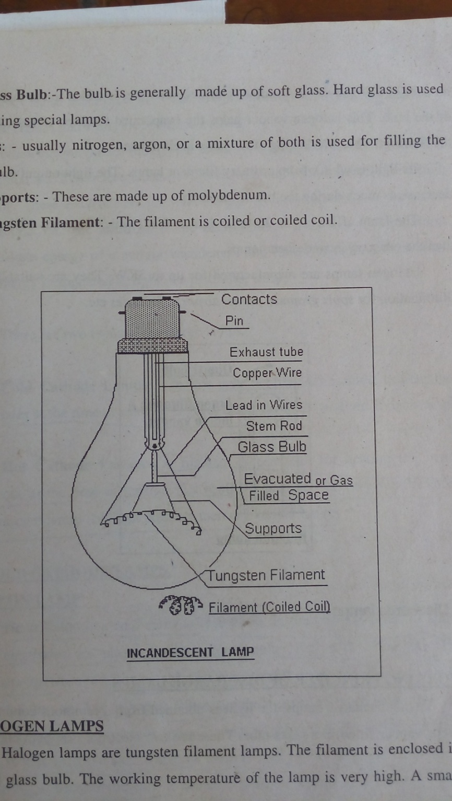

1. **Tantalum**

Melting point of Tantalum is around 3000ºC. But it has a low efficiency.

1. **Tungsten**

Melting point of Tungsten is around 3400ºC. It has high efficiency, positive temperature co-efficient of resistance and low vapour pressure. It can be easily drawn into thin wires. Therefore, tungsten is the most widely used material for filaments.

Typical power ratings of an incandescent lamp are 40W, 60W, and 100W. A gas filled tungsten filament lamp has efficiency of 10-20 lumens/watt. The average life of a modern filament lamp is 1000 Hours.

**Parts of a Gas Filled Incandescent Lamp**

1. **Contacts: -** The supply from mains enters through the contact points.
2. **Exhaust tube: -** Air is exhausted and gas is filled to the bulb through this tube.
3. **Lead in wires:-** Lead-in-wires are used to carry current to the filament. The lead-in-wires are made up of
4. Nickel: - From filament to stem.
5. Copper nickel alloy:- In the glass pinch.
6. Copper: - From glass pinch to contacts.
7. **Stem Rod:-** The lead-in-wiresare taken through the stem tube.
8. **Glass Bulb:-** The bulb is generally made up of soft glass. Hard glass is used for making special lamps.
9. **Gas:-** Usually nitrogen, argon, or a mixture of both is used for filling the glass bulb.
10. **Supports:-** These are made up of Molybdenum.
11. **Tungsten Filament:**- The filament is coiled or coiled coil.

**HALOGEN LAMPS**

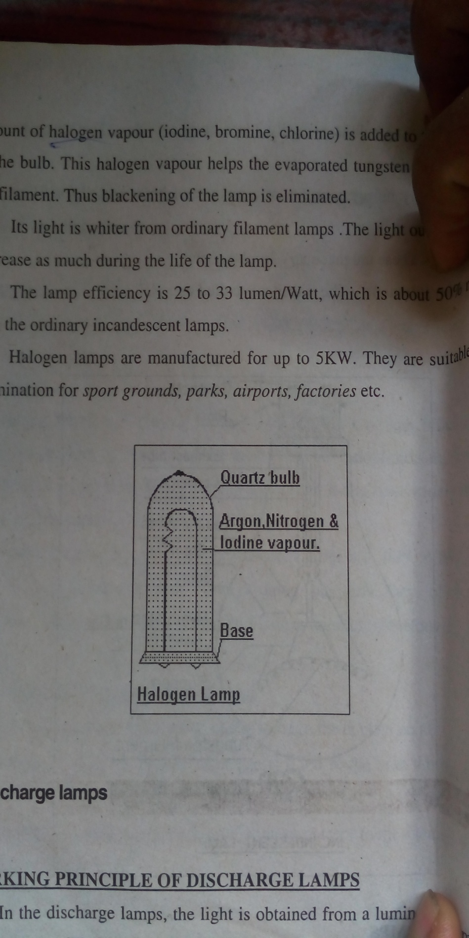 Halogen lamps are tungsten filament lamps. The filament is enclosed in small glass bulb. The working temperature of the lamp is very high. A small amount of halogen vapour (iodine, bromine, chlorine) is added to the inert gas of the bulb. This halogen vapour helps the evaporated tungsten to resettle on the filament. Thus blackening of the lamp is eliminated.

Its light is whiter from ordinary filament lamps. The light output doesn’t decrease as much during the life of the lamp.

The lamp efficiency is 25 to 33 lumen/Watt, which is about 50% more than the ordinary incandescent lamp.

Halogen lamps are manufactured for up to 5KW. They are suitable for illumination for *sport grounds, parks, airports, factories etc.*

**II. Discharge lamps**

**WORKING PRINCIPLE OF DISCHARGE LAMPS**

In the discharge lamps, the light is obtained from a luminous column of gas or vapour filled in a glass tube. There are two electrodes on both ends of the tube. These electrodes are coated with electron emitting material (*like Barium Oxide*) that emits electrons on heating.

When current passes through the electrodes, the electrodes are heated and emit electrons. These free electrons travel from cathode to anode with a high velocity. These electrons collide with the gas or vapour atoms, and the atoms are excited. i.e. The electrons in the neutral atoms get energy. These atoms will radiate energy of a certain wavelength and return to their normal state. This energy is appeared as light in a discharge lamp.

**There are two types of discharge lamps.**

1. **Cold Cathode Lamps**:- In this type no filament is used to heat the electrodes at the time of starting. Eg. (a) Neon Lamp (b) Sodium vapour lamp.
2. **Hot Cathode Lamps**:- A filament is provided for heating the main electrode at the time of sharing. Eg. (a) Low pressure mercury vapour lamp (fluorescent lamp) (b) High pressure mercury vapour lamp.

**(i) COLD CATHODE LAMPS**

**a) NEON LAMP**

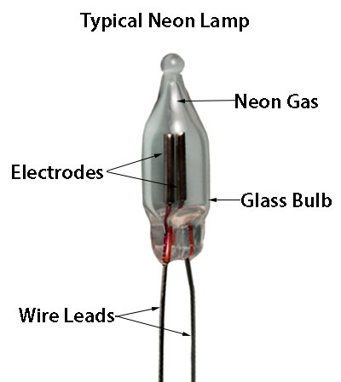 Neon Lamp is a cold cathode type lamp. In this lamp two flat or spiral iron electrodes are placed inside a glass bulb filled with Neon gas. The distance between these electrodes is very small so that the lamp can be operated on very low voltages. When supply is given to these electrodes, the gas will be ionized and emits light. Typical working voltages of Neon Lamps are 100V AC or 150V DC. When the lamp is used in DC, negative electrode is made bigger because the glow is appeared near the negative electrode.

A series resistance is connected (**2KΩ**) to the lamp to reduce the variation in the current.

The neon Lamp is commonly used as indicator lamp or night lamp. The light is orange-pink in colour. The typical power consumption is up to 5W.

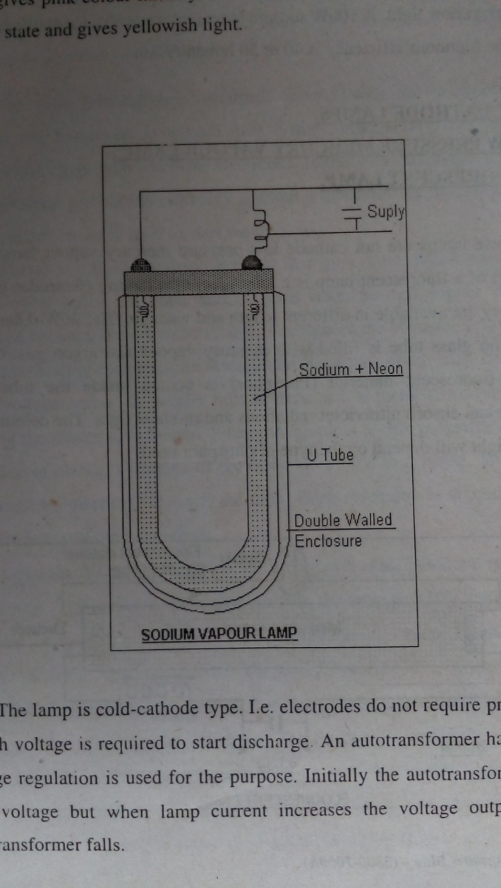**b) SODIUM VAPOUR LAMP**

Sodium vapour lamp is a low-pressure lamp. As low preasure discharge lamp has very low intensity, to obtain a large lumen output the lamp must be in the form of a ‘U’ tube. The efficiency of the lamp is very sensitive to temperature. So the lamp is enclosed in double-walled jacket of glass tube. A little of neon gas is added to sodium inside the tube to start the discharge. Neon gives pink colour initially. After 10-15 minutes, the sodium turns in to vapour state and gives yellowish light.

The lamp is cold-cathode type. i.e. electrodes do not require pre-heating. A high voltage is required to start discharge. An autotransformer having poor voltage regulation is used for the purpose. Initially the autotransformer gives high voltage but when lamp current increases the voltage output of the autotransformer falls.

These type of lamps are normally used as streetlights and park light. They give dark yellow light. A 100W sodium lamp requires 450V for starting.

The luminous efficiency is 40 to 50 lumen/Watt.

**ii)** **HOT CATHODE LAMPS**

1. **LOW PRESSURE MERCURY VAPOUR LAMP**

**FLUORESCENT LAMP.**

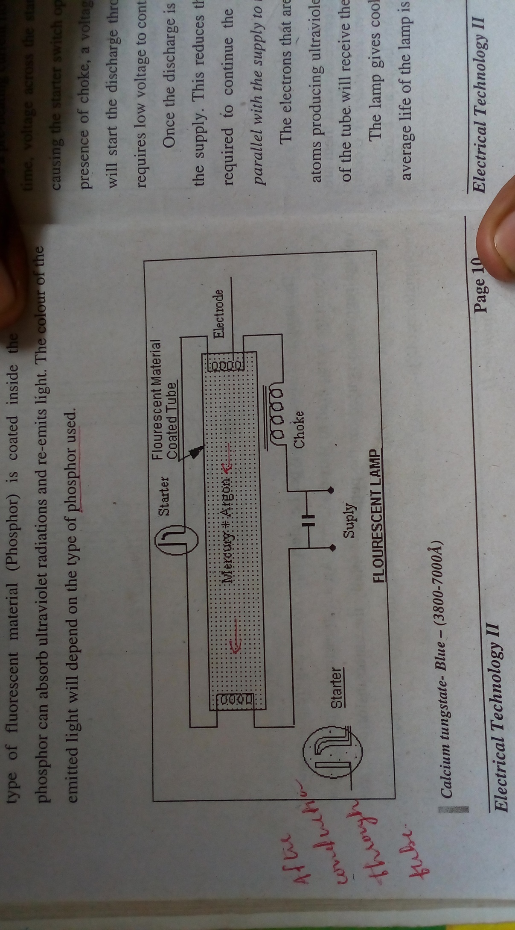

These lamps are hot cathode low-pressure mercury vapour lamps. The main part of a fluorescent lamp is a long glass tube having electrodes on both ends. They are available in different length and wattage. *(Eg: 20W-0.6m, 40W-1.2m).* The glass tube is filled with mercury vapour and argon gas. Certain type of fluorescent material (Phosphor) is coated inside the tube. This phosphor can absorb ultraviolet radiations and re-emits light. The colour of the emitted light will depend on the type of phosphor used.

**FLOURESCENT LAMP**

***Calcium tungstate- Blue- (3800-7000Å)***

***Magnesium tungstate- Blue- white (3800-7200Å)***

***Zinc silicate- Green - (4500-6200Å)***

***Cadmium borate – Pink – (4000-7000Å)***

The tube has tungsten filaments coated with an electron-emitting material like barium oxide on both ends. A high voltage (1000V) is required to start the discharge between these electrodes. Initially the discharge takes place through argon gas because mercury at room temperature exists in liquid form. A starter and choke is used to start the discharge.

Starter is a bi-metal strip electrode in a glow tube. When switch ON the bi-metal strips are cold, and in open state. So full supply voltage is appeared between the starter terminals. This causes the bi-metal strips to touch and a pre-heating current flows through the electrodes of the tube. At the same time, voltage across the starter falls to zero and bi-metal strips cools down, causing the starter switch open. Since the circuit is highly inductive due to the presence of choke, a voltage of the order of 1000V is induced. This voltage will start the discharge through the tube. Once discharge is started, the tube requires low voltage to continue.

Once the discharge is started, the choke acts as an inductive reactance to the supply. This reduces the voltage across the tube to 110V only, which is required to continue the discharge. *(Usually a capacitor is connected in parallel with the supply to increase the power factor.)*

The electrons that are emitted from cathode of tube collide with mercury atoms producing ultraviolet radiations. The fluorescent material coated in side of the tube will receive these radiations and reemits the visible light.

The lamp gives cool daylight and has efficiency of 40 lumen/Watt. The average life of the lamp is about 4000-10000 Working Hours.

**Applications:-** Workshops, Drawing rooms, Offices, General lighting.

**Comparison between Filament Lamps & Fluorescent lamps.**

|  |  |  |
| --- | --- | --- |
| ***Characteristics*** | **Filament Lamps** | **Fluorescent Lamps** |
| *Life* | Up to 1,000 Hours | Up to 10,000 Hours |
| *Luminous Efficiency* | Low (10-20 Lumen/watt) | High (40 Lumen/watt) |
| *Light Output* | Much heat is produced. Makes shadows. | Cool light without shadows |
| *Starting Arrangements* | No starting arrangements are required. | Special starting arrangements are required. |
| *Cost* | Low initial cost. Running cost is high. | Initial cost is high. But running cost is low. |
| *Colours* | Only few colours can be produced. | Depending up on the phosphor used various colours can be obtained. |

**III. ARC LAMPS**

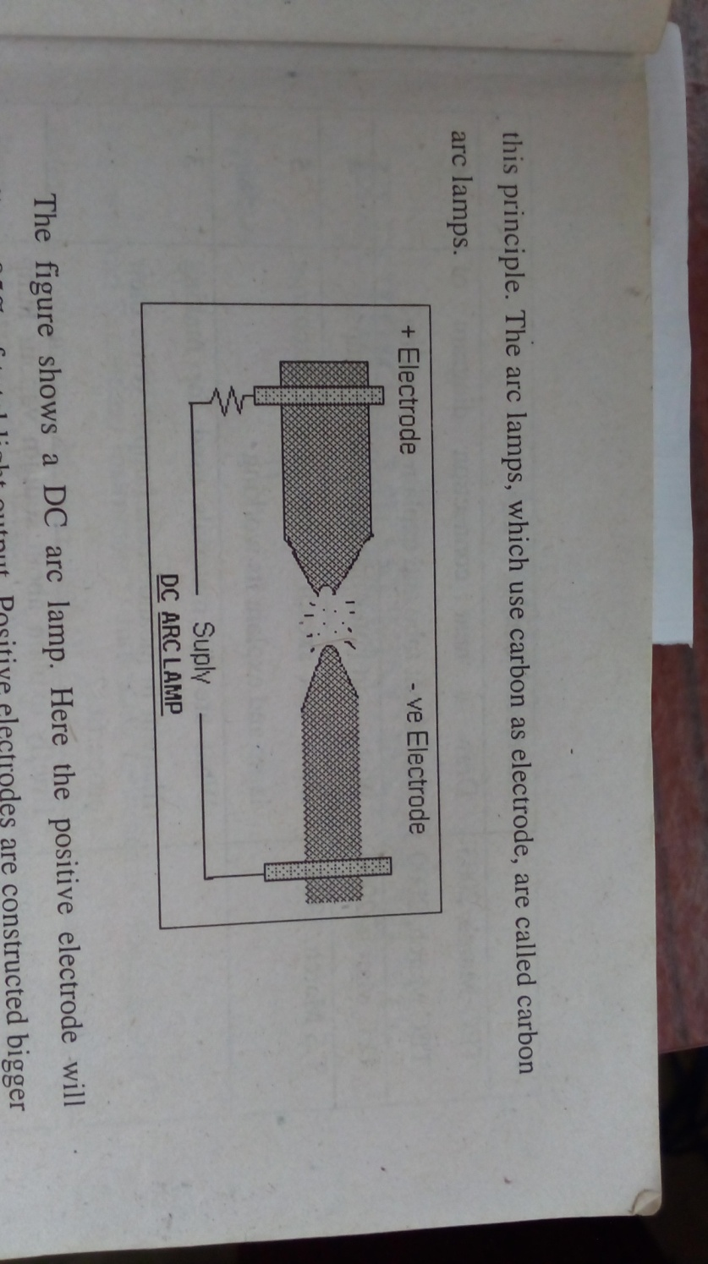 When two electrodes having high potential difference between them are separated with a very short *(typical distance between electrodes is 0.6cm)* distance, a luminous arc will appear between them. Arc lamps are based o n this principle. The arc lamps, which use carbon as electrode, are called carbon arc lamps.

The figure shows a DC are lamp. Here the positive electrode will contribute 85% of total light output. Positive electrodes are constructed bigger than negative electrodes. A constant voltage should be maintained between two electrodes. However, electrodes are shortened after sometime. A mechanism is necessary to keep electrodes at constant distance.

Because carbon has negative temperature co-efficient of resistance, a resistor is connected in series with the electrodes in DC arc lamps.

The efficiency of the arc lamp is higher than incandescent lamp. Operating voltage of the Arc lamp varies between 40 to 60V.

The Arc lamps are commonly used in cinema projectors, search lights etc.

**\*\*\*\*\*\*\*\*\*\*\*\*\*\*\*\*\*\*\*\*\***

**CHAPTER 2**

**ELECTRICAL MEASURING INSTRUMENTS**

**ABSOLUTE INSTRUMENTS & SECONDARY INSTRUMENTS**

**Absolute instruments.**

Absolute instruments give value of quantity to be measured in terms of the constants of the instrument and their deflection only. No previous calibration or compensation is necessary. They are used only within laboratories as standardizing instruments.

Example: Tangent Galvanometer is an absolute instrument which gives value of the current in terms of a) Tangent of deflection b) Radius and number of turns of wire used c) The horizontal component of earth’s magnetic field.

**Secondary instruments.**

Secondary instruments require pre-calibration or comparison with a primary instrument. Their deflection of reading can be used only after calibration.

They are commonly used in everyday work. *Eg: Ammeters, Voltmeters*

**CLASSIFICATION OF SECONDARY INSTRUMENTS**

1. **Indicating instruments.** They will indicate the instantaneous value of the quantity is being measured. Eg. Ammeters, Voltmeters
2. **Recording instruments.**  They will make a continuous record of the quantity is being measured over selected period. Eg. E C G.
3. **Integrating instruments.** They will give the total amount of the electrical quantity consumed over a period. Eg. Watt-Hour meter.

**ESSENTIALS OF INDICATING INSTRUMENTS**

1. **Pointer**

All indicating instruments have a pointer, which is attached to spindle of a moving system, and moves over a scale to indicate the value of quantity to be measured.

**b) Scale**

Indicating instruments have a scale in which the readings are marked. The scale should be calibrated by comparing with a standard instrument.

The scale may be linear or non-linear depending on the type of controlling torque used.

**c) Moving system**

The moving system deflects the pointer. The moving system is pivoted in jewel bearings. Various torques that are acting on the moving system are,

1. ***Deflecting torque. 2. Controlling torque. 3. Damping torque.***
2. **Deflecting Torque (Td)**

This torque deflects the moving system and thus the pointer. It can be produced using various effects of electric current.

Eg: Magnetic, Electro Magnetic, Electro dynamic, Heating and Electro static effects can be used for Ammeters, Voltmeters, Watt meters and Watt-hour meters.

The chemical effect of current is utilized for D.C ampere-hour meter.

1. **Controlling Torque (Tc)**

The controlling torque always opposes deflecting torque and restores the zero position of the pointer. Deflection of the moving system will be indefinite if there is no controlling or restoring torque. The controlling torque increases with the deflection of the moving system. The Pointer comes to rest when the Deflecting Torque equals to the controlling Torque.

The controlling torque ensures that the deflection produced is directly proportional to the current.

**There are two methods for producing controlling torque.**

1. **Spring control.**

In this method, one or two spiral spring (usually made up of Phosphor bronze) is attached to the moving spindle. If one spring is used, it twists in the opposite direction of rotation of spindle. The twist produces the controlling torque, which is directly proportional to the angle of deflection (Tc ∝ θ).

The pointer comes to rest when Deflecting torque and controlling torques are equal.

***Td* ∝ *I (Current) and Tc* ∝ *θ***

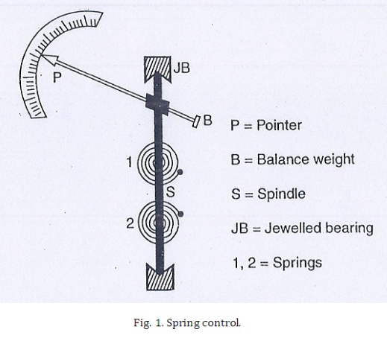***When Td = Tc***

***θ* ∝ *I***

Spring controlled instruments will have uniform scale because the angle of deflection (θ) is directly proportional to current. The springs should i) Non magnetic ii) have low specific resistance iii) have low temperature coefficient of resistance.

1. **Gravity Control**

In this method an adjustable weight is attached to some part of the moving system. This control weight exerts torque due to gravity and opposes the deflection of the moving system. Here the Controlling torque is proportional to the sine of the angle of deflection.

***Tc* ∝ *Sinθ and Td* ∝ *I***

***When Td = Tc, I* ∝ *Sinθ***

Hence Gravity Controlled instruments have scales, which are, not uniform but are cramped or crowded at their lower ends.

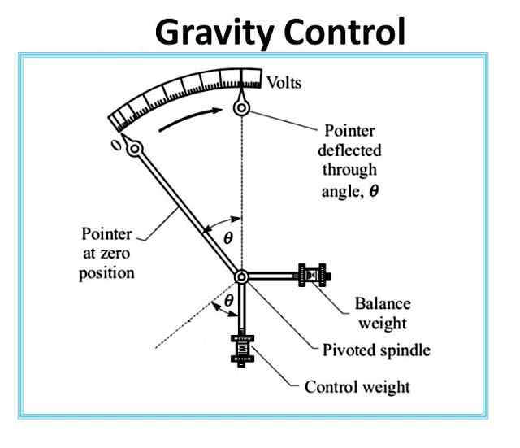**Disadvantages**

1. It gives cramped scale.
2. The instrument has to be kept vertical.

**Advantages**

1. It is cheap.
2. It is unaffected by temperature.

**3. Damping torque**

Damping torque opposes the motion of the pointer and makes the pointer to rest quickly.

It acts only when the moving system of the instrument is under movement. It reduces the oscillation of the moving system due to inertia. The damping torque should be adjusted so that the pointer rises quickly to the deflected position. This is termed as *critical damping.*

The damping forces can be produced by

***i) Air friction damping.***

***ii) Eddy-current damping.***

1. ***Fluid friction damping.***

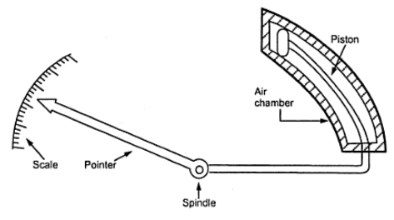**i) Air friction Damping**

There are two methods for air friction damping.

(i) A small air chamber with a light aluminium piston, which is attached to the moving system, provides the damping torque in first method. When the pointer deflects the piston moves through the air chamber (having compression and suction actions). The air resistance provides damping.

(ii) In second method light aluminium vanes are attached on the spindle of the moving system provide damping torque.

**Fluid-friction Damping**

Fluid-friction damping is similar to the air-friction damping but vanes are immersed in fluid of high viscosity. This type of damping is not much used because i) instrument must be kept vertical. ii) Chances for Creeping of the oil.

**Eddy-Current Damping**

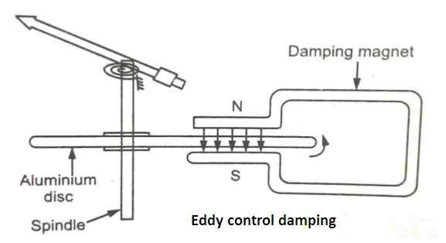

It is the most efficient and widely used method. A thin disc mounted on the spindle is placed between poles of a permanent magnet as shown in the figure. This disc should be conducting but non-magnetic (Eg. copper, aluminium). While rotating the disc cuts the magnetic flux and eddy currents are induced in it. The torque produced by these eddy currents opposes movement of the spindle (Lenz's law). Thus, the damping torque is produced.

**DIFFERENT TYPES OF MEASURING INSTRUMENTS**

In a Measuring Instrument the deflecting torque can be produced using various methods. The commonly used measuring instruments are of following types.

**1. Moving Iron Instrument**

a) Attraction type

b) Repulsion type.

**2. Moving Coil Instruments**

a) Permanent Magnet Moving Coil Instruments. (PMMC)

b) Dynamometer or Electro dynamic Instruments.

**3. Induction type Instruments**

**1. MOVING IRON INSTRUMENTS**

There are two types of Moving iron instruments.

1. Attraction type

2. Repulsion type

For both types a current-carrying coil produces the necessary magnetic field. If this instrument is used as an Ammeter the coil will have fewer turns of thick wire, and if this instrument is used as a voltmeter the coil will have large number of turns of thin wire.

**Attraction type MI instruments.**

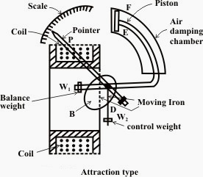An oval-shaped soft iron disc on a spindle is placed between the current carrying coils. The coil attracts the iron piece when current passes through it. This causes the pointer to deflect. Whatever the direction of current through the coil the iron piece is always pulled inwards. Hence such instruments can be used for both AC and DC.

An oval-shaped soft iron disc on a spindle is placed between the current carrying coils. The coil attracts the iron piece when current passes through it. This causes the pointer to deflect. Whatever the direction of current through the coil the iron piece is always pulled inwards. Hence such instruments can be used for both AC and DC.

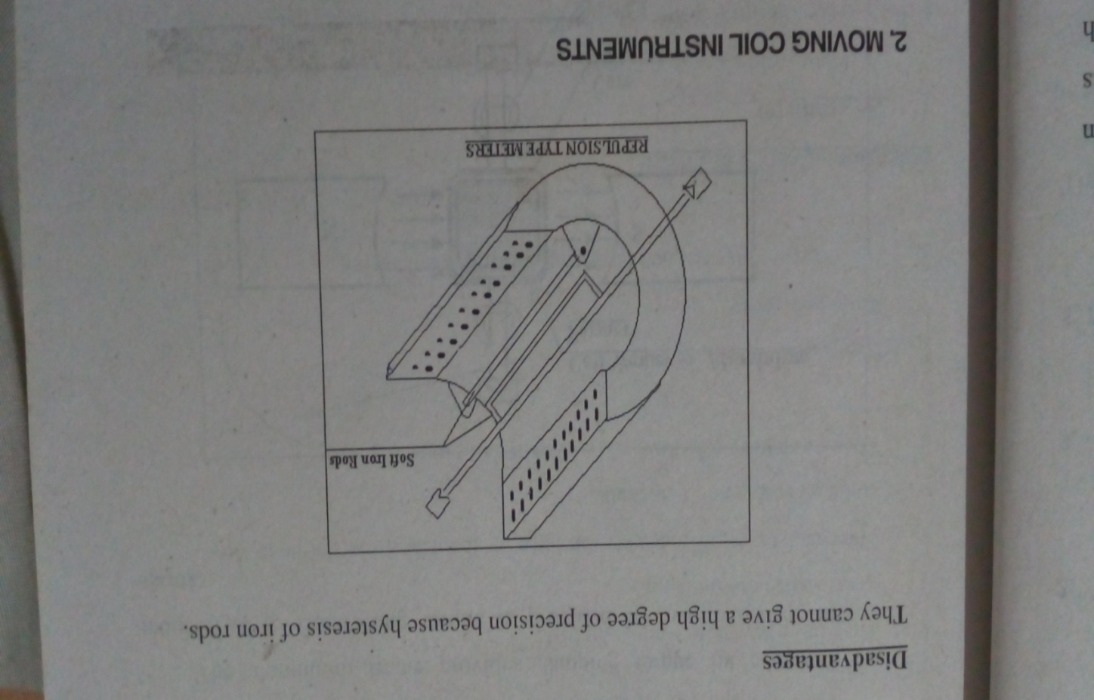**Repulsion type MI instruments**

In the Repulsion type two soft iron rods or strips are placed parallel in the same magnetic field of the coil. One of these strips is fixed and other is attached to the moving spindle. When current to be measured passes through the fixed coil, it magnetizes two strips similarly. The strips repel each other, which causes the deflection of the pointer. The repulsive force is proportional to square of the current through the coil.

This instrument can be used for both AC & DC. Since the deflection torque is proportional to square of the current, their scales are crowded at starting and finishing ends. But if suitably shaped iron pieces are used, uniform scales can be obtained.

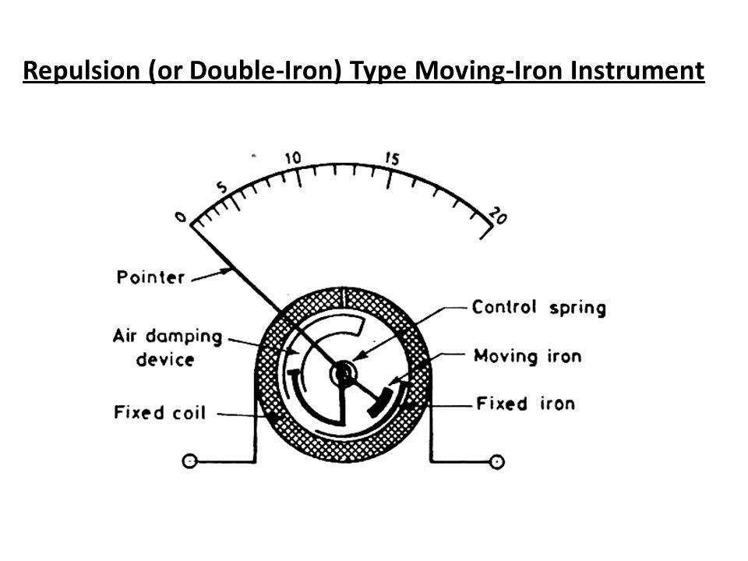

**Advantages of Moving Iron Instruments**

(1) They are cheap

(2) Reliable service

(3) Can be used both AC and DC

**Disadvantages**

They cannot give a high degree of precision because hysteresis of iron rode.

**2. MOVING COIL INSTRUMENTS**

There are two types of Moving Coil Instruments.

(1) Permanent magnet moving coil instruments.

(2) Dynamometer type moving coil instruments.

**PERMANENT MAGNET MOVING COIL (PMMC) INSTRUMENTS**

This instrument consists of a permanent magnet and a rectangular coil of many turns. The coil is wound on a light aluminium or copper former inside which an iron core is fixed. The coil is placed between the end poles (soft iron) of a powerful U-shaped permanent magnet made up of Alnico.

The aluminium frame provides damping torque by eddy-currents induced in it. Controlling torque is provided by two phosphor bronze springs.

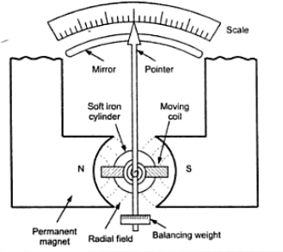

**Deflecting torque**

The moving coil produces deflecting torque when current passes through it.

***The magnitude of deflecting torque (Td)= NBIL X B***

***Td = NBIA Nm***

***Td* ∝ *I ; Td* ∝*Tc ; Tc* ∝ *θ; θ* ∝ *I***

**Advantages**

* They have low power consumption.
* Their scales are uniform.
* They can be modified with the help of shunt and multiplier to cover wide range of voltage and currents.
* They have very effective eddy-current damping.

**Disadvantages**

* They are costly.
* Some errors may set due to ageing of the control spring.

**Extension of range of PMMC**

**1. As ammeter**

A small value resistor connected in parallel with the meter is called shunt resistor. Shunt resistor can increase range of the PMMC meter when it is used as an Ammeter. The value of the shunt resistor can be calculated as Rs= Ig Rg . Where

I - Ig

Ig = Maximum current that can be flowed through the meter.

Rg = Resistance of the meter.

**2. As voltmeter**  
 A high value resistor connected in series with the meter is called Multiplier. Multiplier Resistor can increase the range of PMMC meter when it is used as a voltmeter. The value of the multiplier resistor can be calculated as Rm = V- Ig Rg .

Ig

Where Ig = Maximum current that can be flowed through the meter. Rg= Resistance of the meter.

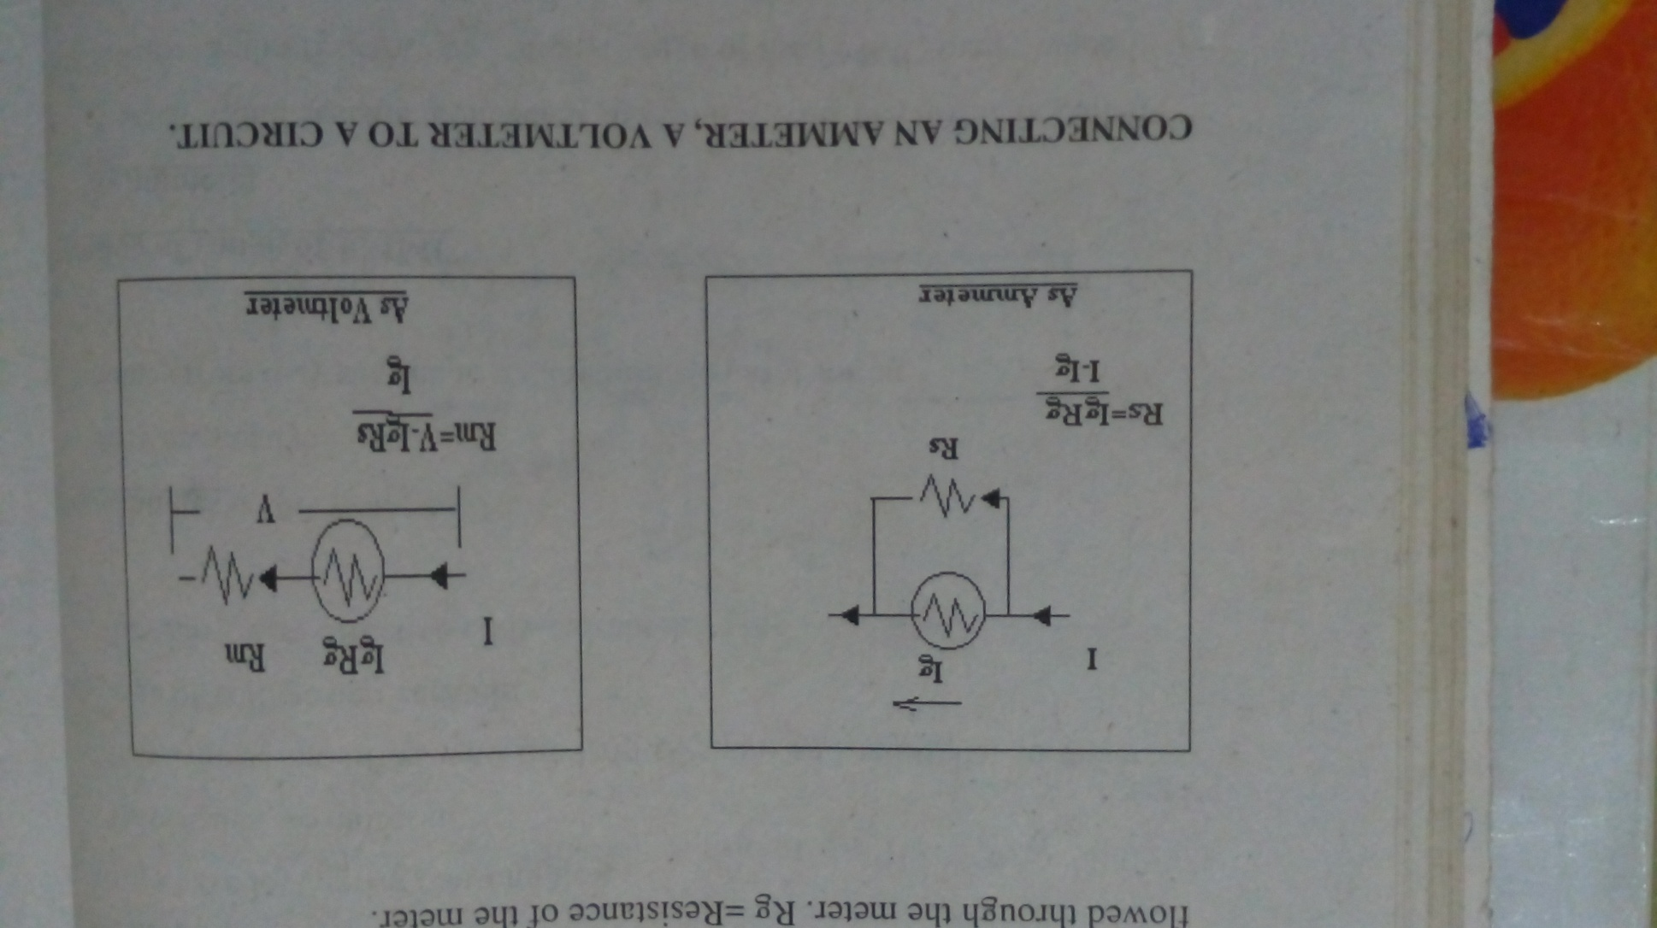

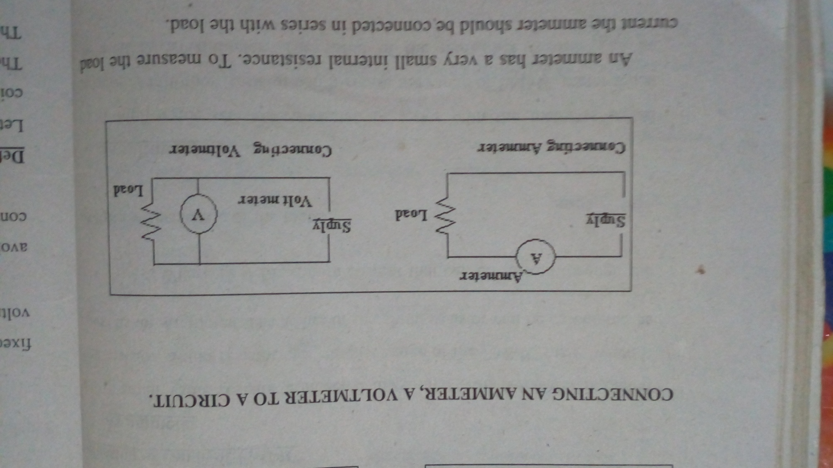**CONNECTING AN AMMETER, A VOLTMETER TO A CIRCUIT.**

An ammeter has a very small internal resistance. To measure the load current the ammeter should be connected in series with the load.

A voltmeter has very high internal resistance. To measure the voltage the voltammeter should be connected in parallel with the load.

**DYNAMO METER OR ELECTRO DYNAMIC TYPE INSTRUMENTS**

In a Dynamo meter type instrument the magnetic field is produced by fixed coils not by permanent magnets. These instruments can be used as voltmeter, ammeter or wattmeter.

The two fixed coils, arranged as shown in the figure are air-cored to avoid hysteresis effect when using in AC circuit. The moving coil is spring controlled.

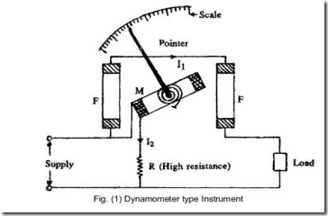

**Deflecting torque**

Let the current passes through the fixed coil is I1 and through the moving coil is I2.

Therefore the field strength is produced by I1.

Therefore flux density B = KI1; K=constant

The torque on the moving coil ***NBI2A*** Nm

When the instrument is used an ammeter the same current passes through both coils are shown in figure I1= I2= I.

When the instrument is used as voltmeter same current passes through both coils are shown in figure I1= I2= I. Here I=V/R

**Advantages and Disadvantages**

1. Free from hysteresis.

2. Torque/Weight ratio is small (Low sensitivity)

**Dynamometer type watt meter.**

*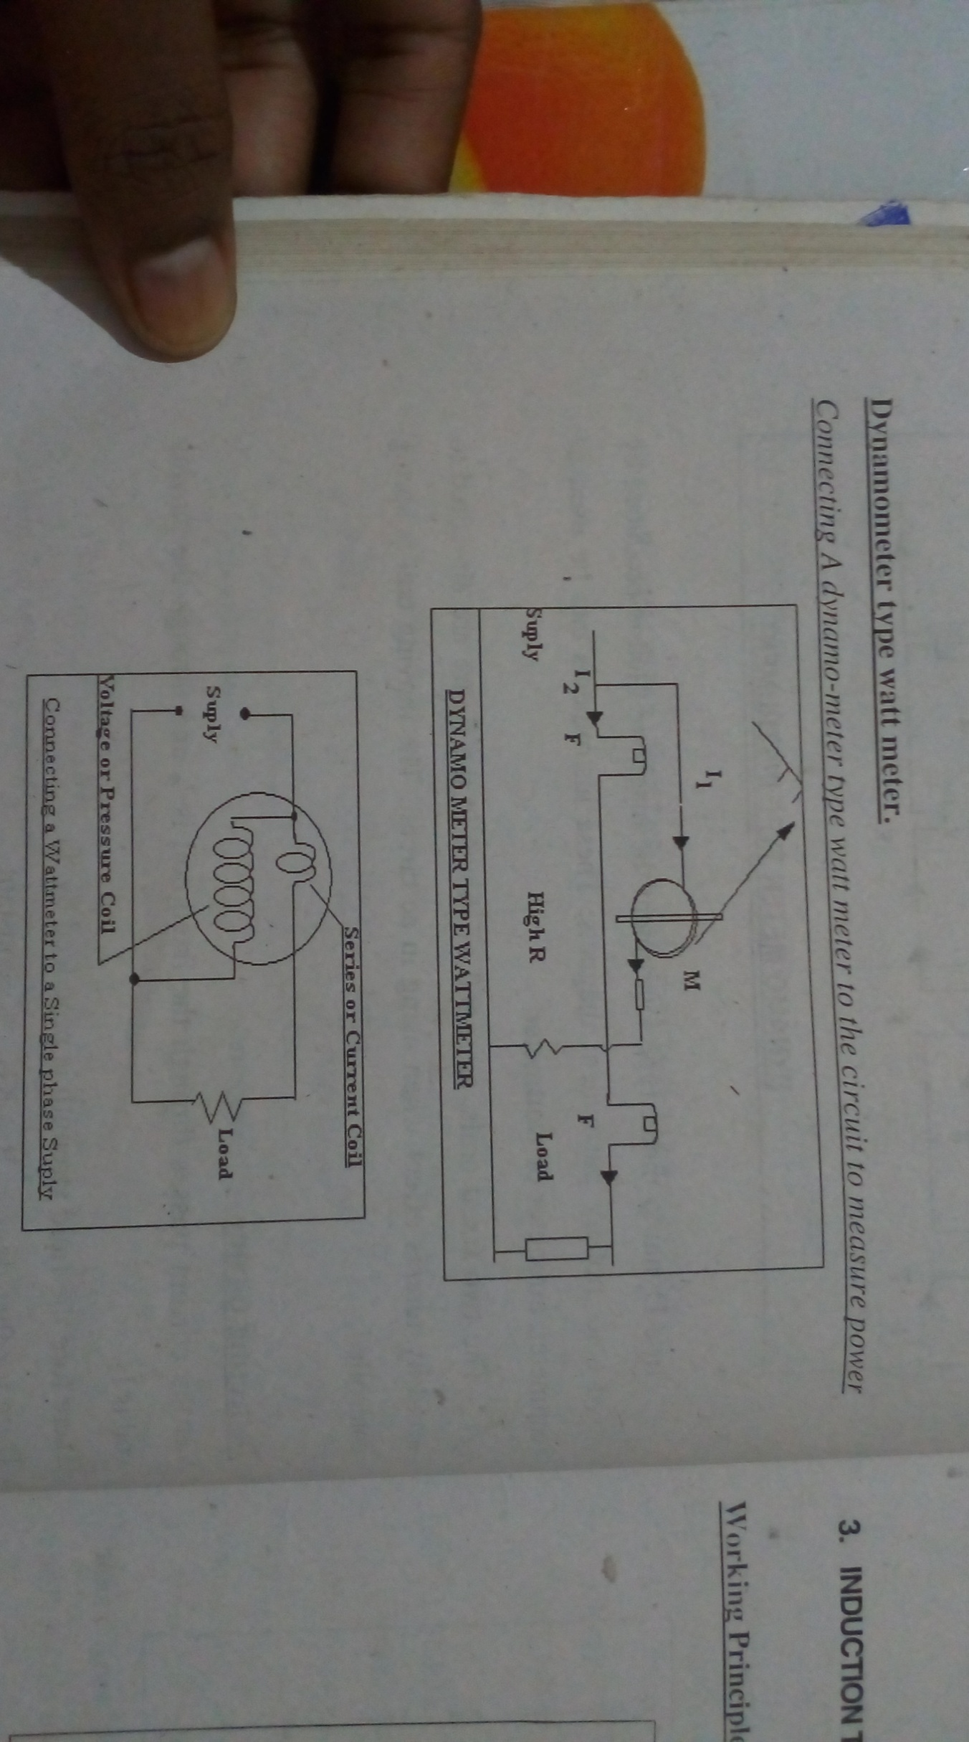Connecting A dynamo-meter type watt meter to the circuit to measure power.*

When a dynamometer type instrument is used as a wattmeter the fixed coil is connected in series with load and the moving coil is connected parallel with the load. So the deflection torque is proportional to the power.

***Torque on the moving coil Td = NBI2A. Here B* ∝ *I2***

***Td* ∝ *N I1 I2 A. Here I1=V/R.***

***Td* ∝ *N (V/R) I2 A. (I2 = The current through the circui*t)**

***Td* ∝ *VI. (Power)***

**3. INDUCTION TYPE INSTRUMENTS.**

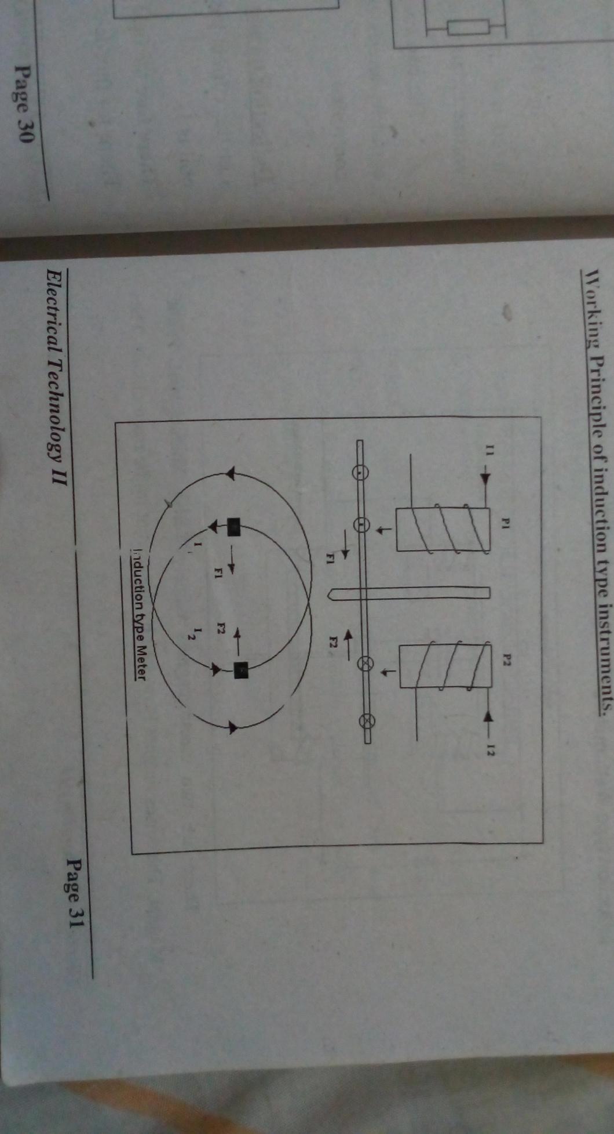**Working principle of induction type instruments**

**Induction type Meter**

These types of meters are used only for AC measurements. They can be used as ammeter, voltmeter, or wattmeter. But they are commonly used as watt-hour or energy meter. In this type of meters the deflecting torque is produced by the reaction between the flux of an AC magnet and the induced eddy currents in a metal disc by this flux.

The magnitude of eddy currents depends on the flux, which is producing them. The instantaneous value of torque is proportional to the square of current or voltage under measurement.

In figure P1 produces flux Ф1 and P2 produces flux Ф2.

The force F1 **∝** Ф1I1 and F2 **∝** Ф2I2.

The resultant torque T = K ωФ1mФ2m sinα.

**Induction type Wattometers**

There are two electromagnets namely Series Magnet and Shunt Magnet. The series magnet is excited by the current in the main circuit. the Shunt magnet is excited by the current, which is proportional to the voltage of circuit.

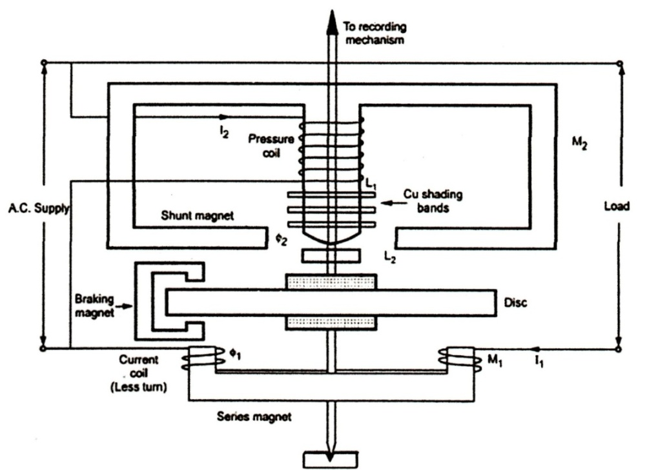

The aluminium disk cuts fluxes of both magnets; hence two eddy-currents are induced in the disc. There are two or three copper rings fitted on the central limb of the shunt magnet. Thus the resultant flux in the shunt magnet will lag behind the applied voltage by 90º.

Here the resultant torque on disc **∝** VI cosФ **∝** Power.

The instrument is spring controlled. Hence deflection (θ) **∝** Power.

**Advantages and Disadvantages of Induction type meters.**

1. A full-scale deflection over 200º can be obtained.

2. Damping - which is made by a permanent magnet at other portion of the disk - is

very effective.

3. They are not much affected by external fields.

4. Their power consumption is large and cost is high.

5. They can be used for AC measurements only.

**Energy Meters.**

Energy meters are integrating type instruments that are used to measure quantity of electrical energy supplied to a circuit in a given time. They give the quantity of energy consumed over a period of time in Kilo Watts (KW).

**Induction type energy meters.**

They are integrating type instruments and used for measuring the total electrical energy consumed over a period.

The principle of these meters is same as that of induction watt meters. (See : Induction Wattmeter) The two are similar in construction. The control spring and the pointer of the wattmeter are replaced with a break magnet and a spindle in energy meter.

In a given period the disk revolves. The total no. of revolutions is proportional to electrical energy consumed.

The register mechanism is either of pointer type or of cyclometer type. In the pointer type a small gear on the rotor shaft drives the pointers. There are five or six pointers rotating on dials marked with ten equal divisions. The gearing between two adjacent pointers is in the ratio 1:10.

**Megger**

It is a portable instrument used for measuring insulation resistance of wirings, machines etc. Normally it is used for measuring resistances in the order of Mega ohms.

**Working Principle**

There are two coils A and B mounted at right angles to each other on a common axis. When current passes through the coils, they produce torques, which are in opposite directions. One of the coils is connected in series to the high resistance under test and is called series or current coil. The other coil is called voltage or pressure coil, which allows a current proportional to the voltage across it.

***The torque of coil A* ∝*I1cosθ***

***The torque of coil B* ∝ *I2 cos(90-θ) = I2 sinθ.***

***Tan θ = I1/I2***

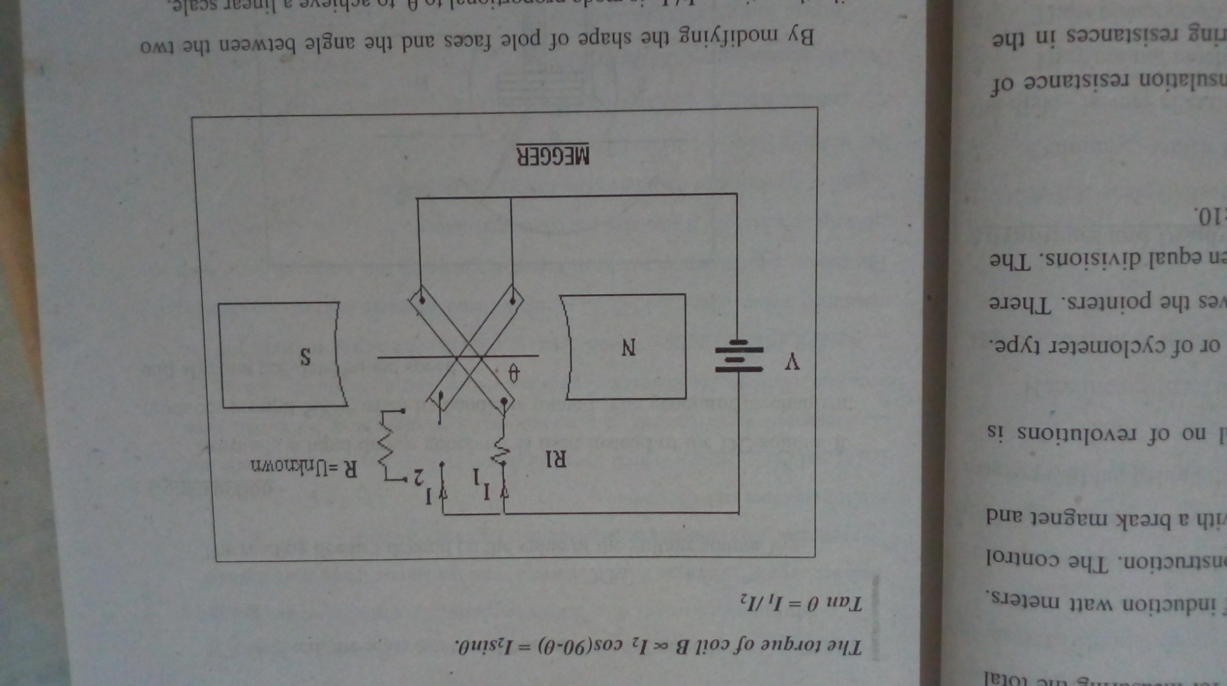

By modifying the shape of pole faces and the angle between the two coils, the ratio **I1/I2** is made proportional to θ to achieve a linear scale.

In figure the two coils are connected across a common source of voltage i.e. battery V as shown in the figure.

The current through the Voltage coil (Coil A) I1=V/R1.

The current through the current coil (Coil B) I2=V/R . Where R may vary from infinity(for good insulation or open circuit) to zero (for poor insulation or short circuit).

The deflection θ of the instrument is proportional to θ = I1/ I2.

θ = V ÷V = R

R1 R R1

If R1 is fixed, the scale can be calibrated to read R directly.

*θ* **∝***R*

The reading doesn't depend on the value of the voltage source V.

**Construction**

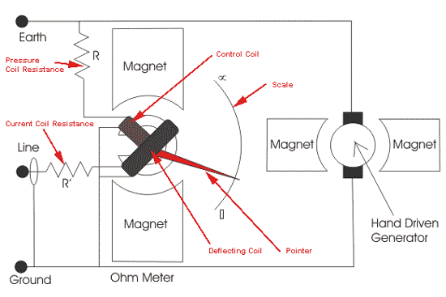

Normally a hand driven generator is used instead of the DC Source. It produces around 500V when its handle is rotated. The generator mechanism will slip at a pre-determined speed.

**Advantages**

Simple to operate, portable, very robust and independent of external supplies.

**Multimeter.**

A Multimeter consists of a Voltmeter, ammeter and ohmmeter. We can measure AC/DC voltage, AC/DC current, and resistance using a multimeter. The required function can be selected using a range switch.

**Multimeters are of two types.**

***1. Digital Multimeter***:- Which uses Liquid Crystal Display (LCD) to indicate the measured value instead of a pointer scale arrangement. So it will give accurate readings. No chances of parallax errors during reading.

***2. Analog Multimeters***:- Which uses a pointer and scale to indicate the measured value. Here a PMMC meter is used to measure various quantities. The meter can be connected in a different ways using the range switch. With the help of a battery it can also measure resistance.

A typical Multimeter may have the following facilities.

DC Voltage Range: <200mv To 1KV.

AC Voltage Range: <200mv To 1KV.

DC Voltage Range: <200µA To 20A.

AC Voltage Range: <200µA To 20A.

Resistance Range: <200Ω To 20MΩ(Continuity Audible indication <100Ω)

Diode test, Transistor hfe test, Frequency measurement.The multi meter is commonly used to test electronic components, circuits and equipments.

**CHAPTER 3**

**SIMPLE AC CIRCUITS**

**Faraday’s first law of electromagnetic induction**

Whenever a conductor cut the magnetic line of force or magnetic flux linked with the circuit changes an emf is induced.

**Faraday’s second law**

The magnitude of the induced emf is directly proportional to the rate of change of magnetic flux linkage. eαdφ/dt, if there is n number of turns in the coil, then induced emf e= -Ndφ/dt. where negative sign indicates the direction of induced emf is opposite to the cause behind it.

**AC FUNDAMENTALS**

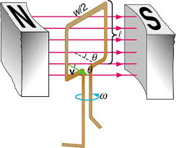 A rectangular coil having N number of turns placed in a uniform magnetic field. When the coil rotates with an angular velocity ω. It cuts the magnetic flux and emf is induced in the coil. In time t seconds the coil rotates through an angle ***θ*** =ω. When the flux is given by,

Φ=φm cos ωt

Φm= BAN, where B is the flux density, A is the area of the coil and N is the number of turns.

Φ=BAN cos ωt

e= -dφ/dt

= -d BAN cos ωt

e = - BAN ω x –sin ωt

= BAN ω sin ωt

BAN ω = e sin ωt

BAN ω = Em e= Emsinωt

= Em sin ***θ*** (ωt= ***θ***)

e= Em sin 2∏ft (ω= 2∏ft), also f= 1/T

1. When the plane of coil perpendicular to the magnetic field then ***θ*** =0, sin ***θ*** =0, then the induced emf e = Em x 0=0v ( ϴ is the angle between the plane of coil and magnetic field)
2. When the coil rotates 90 plane of the coil is parallel to the field then ***θ*** =90 and sin 90=1,then induced emf e= Em x 1= Em
3. When the plane of coil moves 180, the plane of the coil is perpendicular to the line of force and ***θ*** =180, then sin 180 = 0, then induced emf e = Em x 0 = 0 v
4. When the coil rotates 270, ***θ*** =270 and the plane of the coil is parallel to the magnetic lines of forces, sin 270 = -1, e= Em x -1 = - Em.
5. When the coil rotates 360, then ***θ*** =360 and the plane of the coil is perpendicular to the magnetic lines of forces. Sin 360 =0, e= Em x 0 = 0 v.

**WAVE FORM OF AN AC QUANTITY**

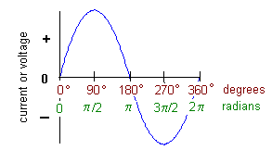

**Cycle:** One complete set of positive and negative values of an alternating quantity is called cycle.

**Time period (T):** The time taken to complete one cycle of an alternating quantity is called its time period. Its unit is seconds.

**Frequency:**

It is the number of cycles per second. Its unit is hertz (Hz).

**Amplitude :**

It is the maximum positive or negative value of an alternating quantity is known as amplitude.

**Peak to peak value:**

It is the difference between positive maximum and negative maximum is known as peak to peak value.

**Phase:**

The various stages of development of an alternating quantity at a given instant during a complete cycle is called phase, which is expressed in radiance.

**Phase difference:**

The difference in phase between two alternating quantity at any time is called phase difference. If the two AC signals attain their maximum and minimum value at the same time then, these quantities are said to be inphase otherwise it is known as outphase.

**RMS value (root mean square value):**

The RMS value of an AC is given by the DC current which when flowing through a given circuit for a given interval of time produces the same heat as produced by the alternating quantity when flowing through the same circuit for the same time.

V rms= Vm/√2= .707Vm, Irms = Im/√2= .707Im

**Average value:**

The average value of an AC is expressed by the dc current which transfer across any circuit the same charge as it is transferred by that AC during the same time. The average value of symmetrical wave form is zero, so the average value of a half cycle is taken.

Vav = 2Vm/∏ = .637Vm

Iav = 2Im/∏ = .637 Im

**Form factor:**

It is the ratio of RMS value to the average value.

= rms value/ avg value

= Vm/√2 x ∏/2Vm

= ∏/2√2= 1.11

Or

= 0.707 Vm/ 0.637 Vm= 1.11

**Crest or peak factor or amplitude factor:**

It is the ratio of maximum value to the rms value.

= max value / RMS value

= Vm/ Vm/√2

= Vm x √2/Vm

= √2 = 1.414

**SERIES AC CIRCUITS**

**Vectors:**

Quantities having both magnitude and direction are vector quantities. A vector is represented by a director line segment. Voltages and current in an AC series circuit are represented using vectors.

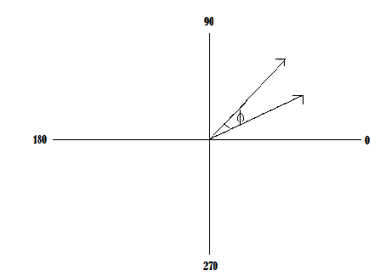

B

A

The figure above shows two vectors with same origin. Here vector A leads vector B by φ where the direction is taken as anti- clockwise.

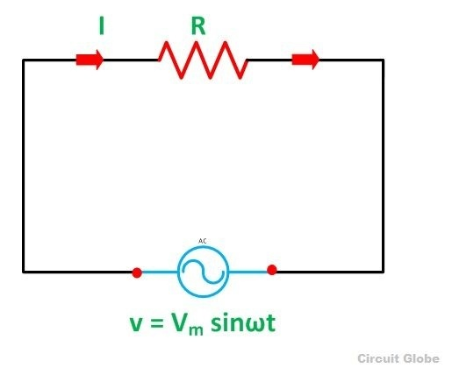**AC THROUGH PURE RESISTANCE ONLY:**

When AC is applied to a pure resistance circuit the voltage and current are inphase with each other.

I=V/R , V = V sin ωt

I = V sin ωt/R

= Vm/R sin ωt

I = Im sin ωt

**Phasor diagram:**

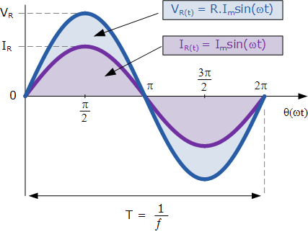

**Vector diagram:**

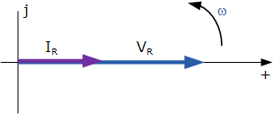

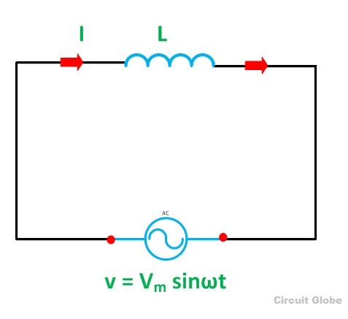**AC THROUGH PURE INDUCTANCE ONLY**

When AC is applied to a pure inductance coil a back emf is produced due to self-inductance of the coil. This back emf opposes the change in current through the coil. Thus current through an inductor always lag the applied voltage by 90. The phasor diagram and wave form shown below.

V = Vmsinωt

Im = Vm/xL

IL = Imsin (ωt-90) [∏/2]

Where X L = 2∏fl, inductive reactance.

**Phasor diagram:**

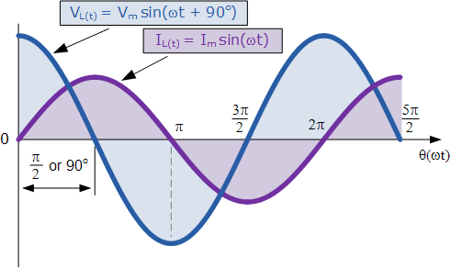

**Vector diagram:**

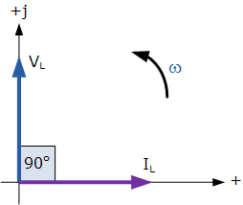

**AC THROUGH PURE CAPACITANCE ONLY**

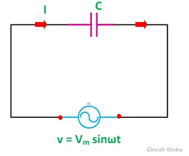When an AC is applied to the plates of a capacitor it will charge first in one direction and then in opposite direction. In pure capacitor circuit the current leads voltage by 90. The phasor diagram and vector diagram are shown below.

Vc= Vmsinωt

Im= $\frac{Vm}{Xc}$ where Xc = $\frac{1}{2∏fc}$ is capacitive reactance

Ic = Imsin(ωt+90)

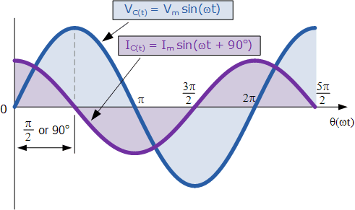**Phasor diagram:**

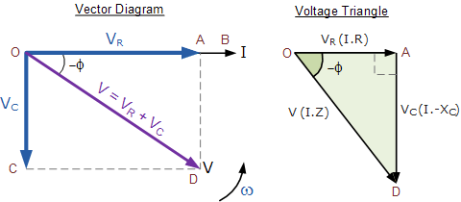**Vector diagram:**

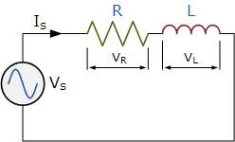**RL SERIES CIRCUITS**

When an AC is applied to an RL series circuit, the voltage across resistor VR and current I are inphase. But voltage across inductor VL leads the current by 90. That is the effective voltage is the vector sum of VR  and VL

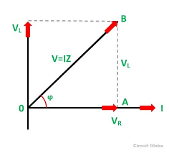By Pythagoras theorem

V2 = (VR)2+ ( VL)2

V =

=

= √I2( R2+XL2)

= I

= Z

That is , Z= $\sqrt{R^{2}+{XL}^{2}}$

Where Z is the impedance of the circuit. Impedance is the total resistance of the circuit.

**RC SERIES CIRCUIT:**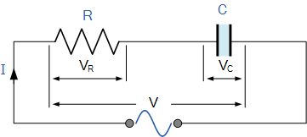

When an AC is applied to an RC series circuit, the current I and the voltage VR is inphase. But voltage VC lag the current by 90. Thus the effective voltage is the vector sum of VR and VC.

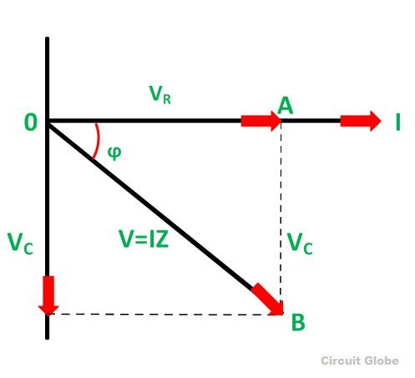 V2 = (VR)2+ ( VC)2

V =

=

= √ I2( R2+XC2)

= I

= Z

That is , Z= $\sqrt{R^{2}+{Xc}^{2}}$

RLC SERIES CIRCUIT:

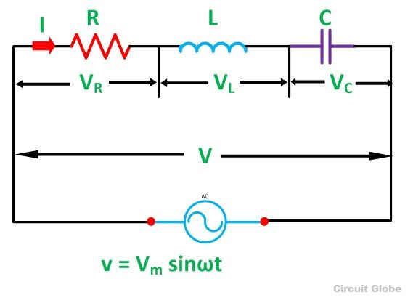In this circuit I is the circuit current, VR is the voltage across resistor, VL is the voltage across inductor, and VC is the voltage across capacitor. VLlead the current by 90 and VC lag the current by 90.

If XL > XC

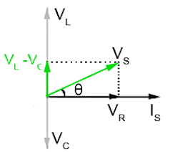

If XC> XL



From the diagram, total voltage

V2= vR2+ (vC-vL)2

V2= (IR)2+(IXc-IXL)2

V=

=

= I

=

Z =

=

=

= IXL –IXc/IR

= $\frac{I(Xl-Xc)}{IR}$

$\tan{ϕ}$ = $\frac{Xl-Xc}{R}$

ɸ = $\tan^{-1}{(Xl-Xc)/R}$

Resonance in an AC circuit:

If the inductive and capacitive reactances are equal then the net impedance will be equal to resistance. Then the circuit current will be maximum and this condition is called resonance condition.

In an RLC circuit,

I = $\frac{V}{\sqrt{R^{2}+{(Xl-Xc)}^{2}}}$ I= $\frac{V}{R}$

At resonance condition, Xl= Xc

I = $\frac{V}{\sqrt{R^{2}+{(Xl-Xc)}^{2}}}$

I = $\frac{V}{\sqrt{R^{2}+o^{2}}}$

I= $\frac{V}{R}$

Xl = Xc

2πfl =

4π2f2LC = 1

f2 =

f=

f =

**POWER IN AC CIRCUITS:**

In an AC circuit if the component of current is inphase with the voltages then it is called active or watt full component. The magnitude of active component is VI $\cos{ɸ}$.

P = VI $\cos{ɸ}$

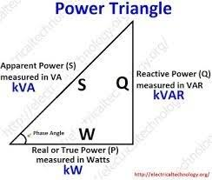 Where ɸ is the angle between voltage and current. If the component of current is out of phase with the voltage by 90, then it is called reactive or watt less or idle component. The magnitude of the reactive component is

P = VI $\sin{ɸ}$

The product of voltage and active current is called active power or true power or watt full power, VI $\cos{ɸ}$. it gives power in kilo watt. The product of voltage and reactive current is called reactive power, P = VI $\sin{ɸ}$. It gives power in kilo VAR ( KVAR).

The product of RMS value of applied voltage and current is called apparent power. This is expressed in kilo volt ampere (KVA).

S2 = P2 + Q2

S =

Apparent power = $\sqrt{{(active power)}^{2}+({reactive power)}^{2}}$

**POWER FACTOR:**

It is defined as the ratio of true power to the apparent power. It is the cosine of angle between voltage and current. And it is the ratio of resistance to the impedance of a circuit.

Pf = $\frac{true power}{apparent power}$

Pf = cosɸ

Pf = R/Z

**COMPARISON TABLE**

|  |  |  |  |
| --- | --- | --- | --- |
| TYPE OF IMPEDANCE | VALUE OF Z | PHASE ANGLE B/W  V AND I | POWER FACTOR |
| RESISTANCE ONLY | R | 0 | R/R =1, COS0 =1 |
| INDUCTANCE ONLY | XL = Lω | CURRENT 90 LAG | COS 90 =0 |
| CAPACITANCE ONLY | XC =1/2Πfc ,  = 1/ cω | CURRENT 90 LEAD | COS 90 =0 |
| RESISTANCE AND INDUCTANCE | Z = $\sqrt{R^{2}+{XL}^{2}}$ | 0<ɸ<90 | 0<PF<1  = R/Z |
| RESISTANCE AND CAPACITANCE | Z = $\sqrt{R^{2}+{XC}^{2}}$ | 0<ɸ<90 | 0<PF<1 |
| RESISTANCE, INDUCTANCE AND CAPACITOR | Z = $\sqrt{R^{2}+{(Xl-Xc)}^{2}}$ = $\sqrt{R^{2}+{(Xc-Xl)}^{2}}$ | 0<ɸ<90 | 0<PF<1 |

**CHAPTER – 4**

**AC GENERATOR**

**AC FUNDAMENTALS**

Alternating voltage can be generated by rotating a coil in the magnetic field or by rotating a magnetic field inside a stationary coil. The value of voltage generated depends up on number of turns in the coil, strength of the field and the speed at which the coil or magnetic field rotates.

**FARADAY’S LAW OF ELECTRO MAGNETIC INDUCTION**

“The e.m.f induced in a conductor placed between magnetic field is given by rate of change of flux linkage of the conductor”.

E= -dϕ

dt

**ADVANTAGES OF ALTERNATING CURRENT OVER DIRECT CURRENT**

**Alternating current has the following advantages over Direct Current.**

1. AC Generators (alternators) have no commutators (Split rings). Therefore they have larger power ratings and heavier current rating without arcing of brush.
2. They are capable of generating high voltages such as 11000 to 13800 Volts.
3. Alternating energy can be transmitted economically over great distance.(It can be easily stepped-up or down).
4. AC motors are less expensive than DC motors.

**FLEMING’S RIGHT HAND GENERATOR RULE**

Position the thumb, first finger and middle finger of right hand at right angles to each other. If thumb indicates direction of motion of conductor and first finger indicates magnetic field then middle finger will point direction of induced e.m.f.

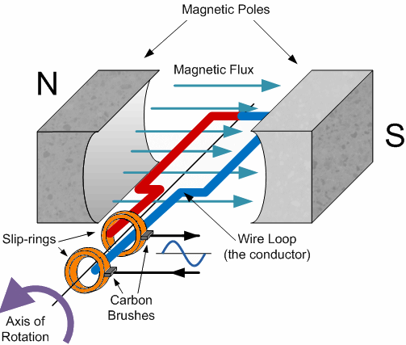**WORKING PRINCIPLE OF A SINGLE LOOP AC GENERATOR**

Figure shows a single loop AC generator. Here a loop is placed between the poles of a permanent magnet. Two ends of the loop are connected to slip rings. Carbon brushes are pressed against these slip rings, which carry electricity to the external circuit. Usually the loop is wound on a core and is called Armature.

When the coil is rotated between the poles, according to faraday’s law of electromagnetic induction an e.m.f is in the coil. The direction of the e.m.f is induced in each segment of the coil can be found out using Fleming’s right hand generator rule.

**Development of a Cycle**

* No e.m.f is induced. Because the conductor moves in the same direction of the magnetic lines of force. Rate of change of flux linkage is minimum.
* Maximum e.m.f is induced. Conductors move at right angle to the magnetic lines. Rate of change of flux linkage is Maximum.
* Rate of change of flux linkage is minimum. Thus induced e.m.f is zero.
* Maximum e.m.f is induced. Conductors move at right angle to the magnetic lines. Rate of change of flux linkage is maximum. Here the current flow through the conductors AB, CD are get reversed because their positions are interchanged. Hence the current flow through the load is reversed.
* Zero e.m.f is induced. One cycle is completed. The slip rings and brushes will transfer the induced e.m.f in the conductors to the external circuit.

**Parts of Alternator**

In modern machines, the armature is kept stationary and the field rotates under it.

**An alternator has following parts.**

1. Stator 2. Rotor 3.Exciter

**Stator :** The stationary part of the alternator in which the e.m.f is induced is known as stator. The stator is made up of laminated stampings insulated from each other with varnish and housed in the yoke. The slots to take windings are cut round the inner surface.

**Rotor:** The rotor has rotating magnetic field poles. These field poles are excited by a DC generator called Exciter. There are two types of rotors.

1. Salient-pole-rotor: - Suitable for slow speed machines (375 – 500 rpm)
2. Cylindrical pole rotor: - Suitable for Turbo Generators (1500 – 300 rpm)

**Exciter :** The exciter is dc shunt or compound generator, which excites the field poles. In small alternators the exciter is mounted on the same shaft or the alternator. For High voltage alternators separately excited generator is used as exciter. The DC supply from the exciter is supplied to the field winding. The voltage rating of the exciter is usually varies from 110 to 250V DC.

**Frequency :**

The number of cycles per second is called frequency of the alternating quantity. Its unit is Hertz(Hz). The frequency is given by the reciprocal of time period of an alternating quantity.(f=1/T)

If an alternator has P poles then the number of cycles produced in armature in one revolution is P/2 cycles. If armature makes N revolutions per minute (or N/60 Revolutions per second) then the

Number of Cycles produced per second = $\frac{P}{2}$*x $\frac{N}{60}$*

f = $\frac{NP}{120}$

**Poly phase Circuits**

A 3–phase alternator has 3 independent armature windings, which are placed 120 electrical degrees apart. Hence, phase difference between the voltage induced in these windings will be 120º. All modern generators are practically 3-phase. The reasons for 3ϕ instruments used widely are:

1. In single-phase circuits, power may become zero, which is undesirable in the power circuit.
2. 3ϕ transmission line is more efficient and requires less copper for transmission of the same amount of power over the same distance.
3. In 3ϕ motors, the torque produced is rotating and uniform where as in single-phase motors it is pulsating.
4. Polyphase motors are self- starting but single-phase motors are not.
5. It is easy to synchronize the poly phase alternators.
6. Poly phase motors use less material, cost less, and they take less current.

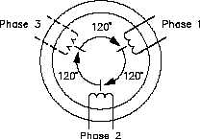

Poly phase Alternator

Eb = EmSin(ωt – 1200)

Ec = EmSin(ωt – 2400)

**Phase Sequence**

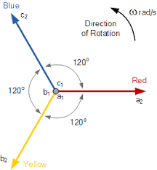The order in which 3 phases attain their maximum values is called phase sequence or phase order. Phase order is written as

abcabca OR a→b→c→a

In the above vector diagram the phase sequence is abcabca OR a→b→c→a. To reverse this phase sequence (i.e. c→b→a→c) any two phases may be interchanged.

The phases are commonly numbered as 1-2-3 or R-Y-B

**Interconnection of 3ϕ**

General methods of interconnecting 3ϕ are

1. Star or Y-connection
2. 2. Mesh or delta () connection
3. **Star or Y- connection**

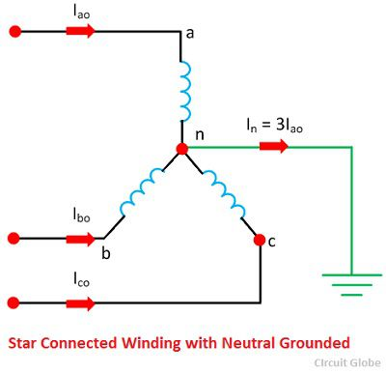In this connection the similar ENDS OF 3- windings are joined together at a point N known as star point or neutral point.

The voltage induced in each winding is called phase voltage and the current flowing through each winding is called phase current (Vph andIph)

The voltage between any two lines (o/p terminals)is called line voltage.the current flowing through eachn line is called line current(Il,Vl)

In a star connection

1. IR+IY+IB=0
2. Line current is equal to phase current Iph=IL
3. LINE VOLTAGE VL=3Vph
4. Total power =3 X phase power +3Vph Iph cosɸ=3 VlIl cosɸ.
5. **Delta or mesh connection**

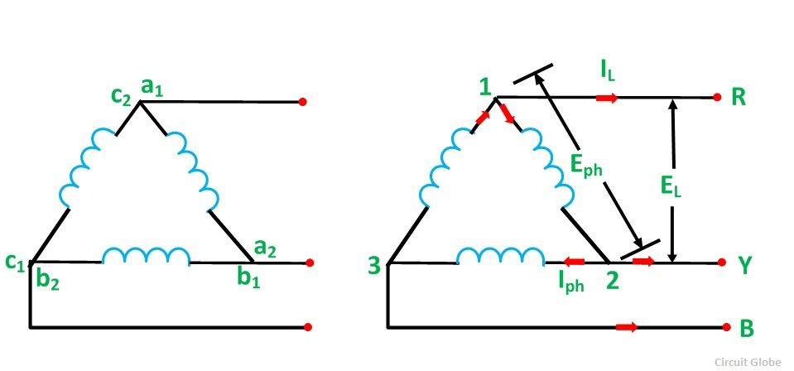In this form, the dissimilar ends of 3 windings are joined together. That is starting end of one phase is joined to finishing end of other phase.

In delta connection

1. Phase voltage(voltage across each winding ) will be equal to line voltage Vph=VL
2. Difference of phase current is equal to line current.IL=IB-IR=3Iph
3. Power= 3X phase power=3Vph Iph cosɸ=3 VL IL cosɸ

where cosɸ is the angle between phase voltage and phase current.

**CHAPTER 5**

**DC GENERATOR**

A Generator which produces unidirectional supply in DC is known as DC generator. A dc generator has two main parts

**1. Armature**

**2. Field Magnet**

There are two types of DC generator. If the magnetic field is provided by a permanent magnet is known as magnetic machine. If the magnetic field is provided by an electromagnet, it is known as dynamo. In dc generator magnetic field is produced by a field magnet, when the coil rotate an emf is induced in the coil, due to Faraday’s law of electromagnetic induction. The direction and magnitude of emf changes, according to the different positions taken by the coil. In order to get direct current at load we are using split rings (commutator). Instead of slip rings, in case of ac generator the split rings are converted ac to dc.

**MAIN PARTS OF MODERN DC GENERATOR**

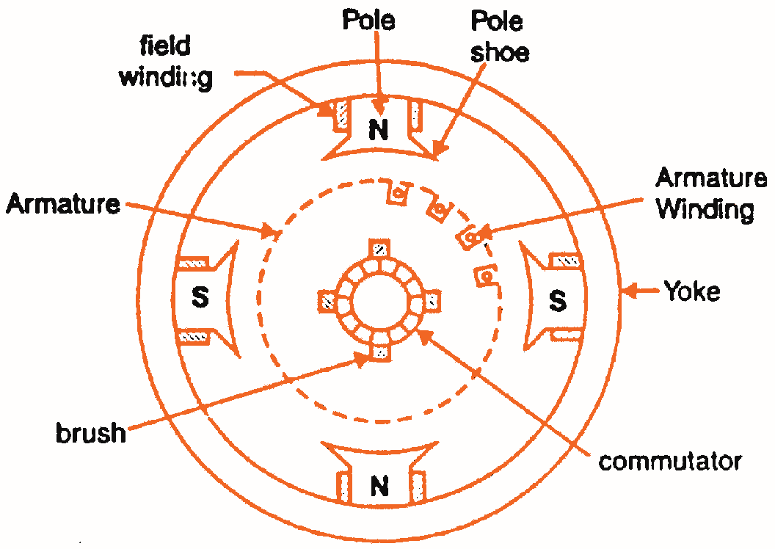**Yoke:** It provides mechanical strength and it acts as a magnetic circuit between poles. It is made up of cast iron or steel.

**Field coil:** The armature winding generate an emf by cutting the magnetic field. When the armature rotates. This magnetic field is provided by electromagnet called field poles. It consist of

1***. Pole core***

***2. Pole shoe***

***3. Field coil***

**Armature:** it is a cylindrical laminated iron stretcher which consists of many slots. The armature winding is embedded in these slots. Voltage induced in these windings. There are two types of winding

***1. Wave winding***

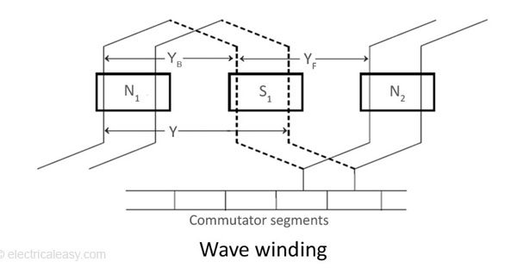 ***2. Lap winding***

**Wave winding**: In these winding the armature conductors are divided into two parallel parts between the positive and negative brushes irrespective of the number of poles of the machine. It provide high voltage and low current.

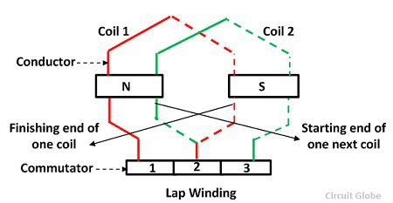**Lap winding:** In this case the armature conductors are divided into so many parallel parts as the number of poles of the generator. if there are ‘P’ poles and ‘z’ armature conductors then there are ’p’ parallel path consist of z/p conductors connected in series between the positive and negative set of brushes.

**Commutator:** It consists of series of copper segments which are insulated from one another and the shaft. The commutator rotates with the shaft and the armature winding. Its function is to convert the induced AC voltage into DC voltage at the generator output terminal.

**Brush:** It is used to supply the current to the external circuit from the commutator

**Emf equation for DC generator**

Let ϕ = magnetic flux density in webber

Z = total no of conductors

P = Number of pole

A = number of parallel paths in armature

N = armature rotations in rpm

Eg= emf induced in any parallel path in the armature

Flux cut per conductors in one revolution = Pϕ webber

Thus dϕ = Pϕ

Number of revolutions per second = N sec

60

Hence time taken for one revolution is 60 sec

N

i.e dt = 60

N

e.m.f generated per conductor

Eg = dϕ

dt

= Pϕ

60

N

= Pϕ X N

60

= ϕPN

60

Number of conductor in one parallel path = Z

A

Thus e.m.f generated per path = Z X ϕPN

A 60

Eg = ϕNZ X P

60 A

**For wave wound generator**

Number of parallel path = 2

A = 2

Number of conductors in path = Z

A

Thus the e.m.f generated per path

Eg = ϕNZ X P

60 A

Eg = ϕNZ X P

60 2

Eg = ϕNZP

120

**For lap wound generator**

Number of parallel path , A = 2

Number of conductors in path = Z

P

Thus the e.m.f generated per path

Eg = ϕNZ X P

60 A

Eg = ϕNZ X P

60 P

Eg = ϕNZ

60

**Types of generators**

**1. Separately excited**

**2. Self excited**

1. **Series wound**
2. **Shunt wound**
3. **Compound wound** 
   1. **Short shunt**
   2. **Long shunt**

**Separately excited generator**

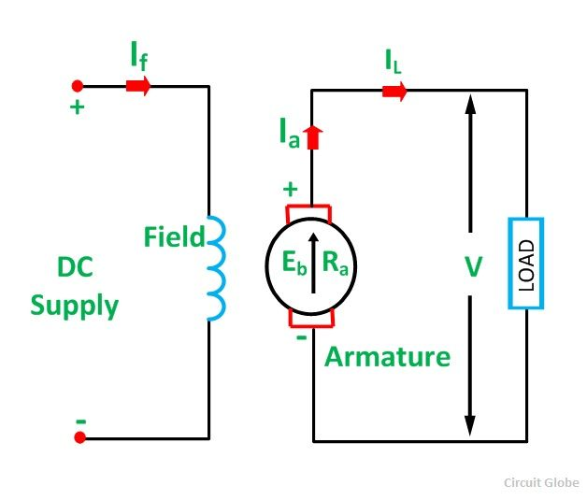 When the field coils are excited from a dc source the generator is called separately excited generator. Here

E = emf generated in armature

Vt = terminal voltage across load resistor

Ia = armature current

Ra = armature resistance

E = Ia Ra + Vt

**Applications:** electroplating, boosters in turbo generators

**Self excited**

If the field coils are excited by the generator itself it is called self excited generator. They are divided into three

1. **Series wound generator**

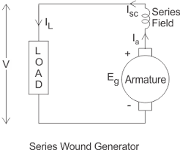 In series wound generator the field winding is connected in series with the armature. Thus the current through the armature and field windings are same. The field winding is made up of thick wires with few turns. The current through the field winding is zero if the generator is in open circuit. So the series generator must always start on the load otherwise the field poles fails to excite.

E = Ia Ra + Vt+ IaRse

Vt = E - Ia Ra - IaRse

= E – Ia (Ra + Rse)

Where Rse is the resistance in series field

**Applications:** lightning arc lamp, constant current source, boosters in Dc transmission

1. **Shunt wound generator**

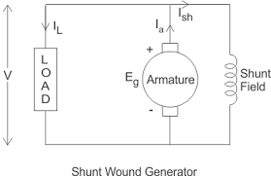 In this type of generator the field winding is connected in parallel with the armature. The field winding is made up of thin wires with many turns. When the armature is rotated a small amount of emf is induced in the field coils. After sometimes the emf increases to its rated value. A shunt generator shall not be started with load, otherwise the field poles fails to excite.

Here the armature current,

Ia = Ish + IL , Vt = E- IaRa

**Applications:** ordinary plating, charging purpose, electroplating and welding.

1. **Compound wound generator**

A compound wound generator has a series field winding and a shunt field winding on the same pole piece. The shunt winding gives a terminal voltage, which falls off with increase in load current. If the series winding just compensate the decrease in the terminal voltage then the generator is said to be level compound. Based on the connection of the shunt and series windings, compound wound generators can be classified into two

**1. Short shunt compound generator**

**2. Long shunt compound generator**

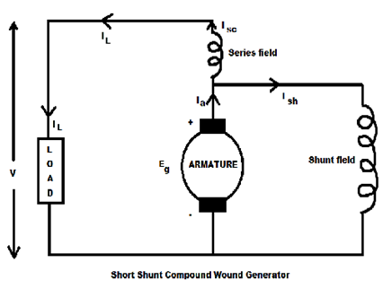 In both cases, the series winding can be connected in such a way that it opposes or supports the flux produced by the shunt winding.

**Short shunt compound generator**

In this circuit the shunt coil is placed directly across the armature and a series coil is placed series with the armature.

E = VT + IaRa + ILRse

Vt = E - IaRa - ILRse

**Long shunt compound generator**

In this circuit, the shunt coil is placed in parallel with both armature and series coil.

E = VT + IaRa + IaRse

E = VT + Ia (Ra + Rse)

**Application:**

* Heavy power lines in electric railway.
* Motor driver in incandescent lamp.

**Losses in dc generator**

**1. Copper losses.**

a) **Armature copper loss:-** Ia2Ra, power dissipated across the armature winding.

b**) Field copper loss:-** Ish2Rsh in a shunt field and Ise2Rse is in series field.

**2. Magnetic or iron core losses**

a) **Hysteresis loss:-** Losses due to hysteresis of the armature of the field magnet

b) **Eddy current loss:-** Power loss due to the eddy current sets up in the armature and field

magnet.

**3. Mechanical losses**

a) Friction at bearings and commutator

b) Windage of rotating armature

**Hysteresis loss**

This loss is due to the reversal of magnetization of armature core. Every portion of the rotating cores passes under north and south poles alternatively. There by attaining south and north polarity respectively. The core undergoes one complete cycle of magnetic reversal after passing under one pair of poles. If p is the number of poles and N is the armature field in rpm, then frequency of magnetic reversal f=PN/120. The loss depends upon the volume and grade of iron and maximum flux density and frequency of magnetic reversal.

**Eddy current losses**

When the armature core rotate it also cut the magnetic flux. Hence an emf is induced in the body of the core. According to the low of electromagnetic induction this emf setup large current in the core due to its small resistance. This current is eddy current or back emf. The power loss due to flow of this current is the eddy current loss. In order to reduce this loss the core is build up of thin laminations. This core laminations are insulated from each other by thin coating of varnish. It depends on maximum flux density, frequency of magnetic reversal, thickness of each lamination and volume of armature core.

**Armature reaction**

It is the effect of magneto motive force set up by the armature current. The armature flux react with the main field flux and destroy it. This will lead to excessive sparking at the brushes and weakend the generated emf. The demagnetizing effect of armature reaction is neutralized by adding a few extra turns to the main field winding. In small machines to avoid this correct the position of the brushes.

**Commutation**

The process by which the current in the short circuited armature coil is reversed while it crosses the magnetic neutral axes is called commutation.

While commutator rotates if a brush contact with two or more commutator segments then the coil connected to these segments are short circuited. After this, the current on these coils changes their direction. If this change is gradual it is called smooth commutation. If this change is sudden then it is called sudden commutation. This leads to sparking at brushes .

**CHAPTER 6**

**DC MOTORS**

**Working Principle of DC Motor**

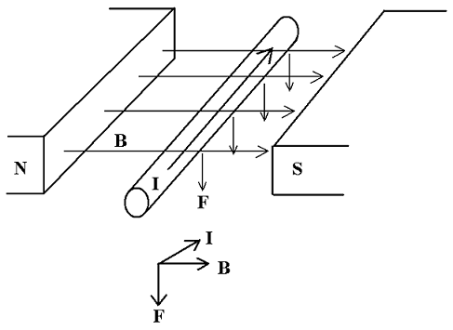 A motor is a machine that converts electrical energy to mechanical energy. Consider a current carrying conductor placed in a magnetic field. The conductor produces its own magnetic field. The direction of this field can be determined by **corkscrew rule**. *(If a screw advances in the direction of current then the magnetic field can be determined by direction of rotation of the screw)*

The magnetic field produced by the current carrying conductor reacts with the main field. The resultant magnetic field is not uniform and this field tend to move the conductor. The direction of the force developed in the conductor can be found by Fleming's left hand rule.

**Fleming's Left hand rule**

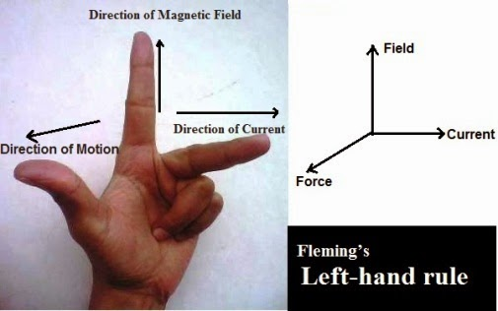 Using Fleming's left hand rule, we can find the direction of force developed on a current-carrying conductor that is placed in a magnetic field. Stretch out the central finger, forefinger and thumb of the left hand to be mutually perpendicular. Then the first is along the current, second field, and third motion. The magnitude of this force is given by

***F=BIL***

***B= Flux density. (Weber/m2)***

***I=Current (Ampere)***

In the figure, a sectional view of a loop of wire is shown which is placed between North and South Pole. The force experienced in each conductor can be determined by Fleming's left hand rule. The net torque produced will tend to rotate the loop in anti-clockwise direction. A DC, motor consists of many loops in order to obtain a continuous motion.

When loop AB starts rotating after very short time conductor B will come under North Pole and conductor A under South Pole. However, with the help of split rings the currents through the conductors are made same as previous. Hence the torque produced is again anti-clockwise.

**Back e.m.f or counter e.m.f**

When the armature of the motor rotates the armature conductors cut the lines of force of the field and as a result they have e.m.f induced in them. The direction induced e.m.f in an individual conductor is given by Fleming's right hand rule. By applying this rule, we can find out that the induced e.m.f will opposes the applied voltage.

The induced e.m.f in the case of a motor is called the back e.m.f. The supply has to do work against this back e.m.f in forcing the current through the armature.

If the induced e.m.f in an Armature is opposite in direction to the current, then the machine is motoring. If it is in the same direction as the current then the machine is generating.

The amount of back e.m.f can be determined by the e.m.f equation of the generator which is given by

Eb = φNP Z

60 A

The back e.m.f is always less than the applied voltage because if two are equal, there will be no current flow through the armature.

i.e Applied Voltage (V) will be the sum of Back e.m.f and Armature voltage drop.

V=Eb+IaRa

Here

Eb = φNP Z

60 A

We can find out the speed N of the motor

N = 60A Eb N = K Eb Where K= 60A

PZ φ φ PZ

***N= Speed of motor (rpm or revolutions per minute).***

***ϕ= Flux per Pole.***

***P= Number of Poles.***

***Z= Total Number of Conductors.***

***A= Total Parallel Paths.***

***Eb= Back e.m.f induced in the armature.***

***Ia= Armature Current.***

***Ra= Armature Resistance.***

**Power Developed in a motor**

In a DC Motor applied voltage will be the sum of Armature drop and Back e.m.f.

V=Eb+IaRa ...........................................(1)

*Multiplying both sides with Ia*

V.Ia=Eb.Ia+Ia2.Ra ................................(2)

***VIa = Total power supplied to the Motor.***

***EbIa = Electrical power Converted to Mechanical power.***

***Ia2Ra= Power dissipated as heat due to armature resistance.***

**Torque**

Torque may be defined as the twisting effect of force about an axis. It is a vector quantity. It is measured by the cross product of force and radius at which force acts.

**Torque = F X r**

***F = force acting.***

***r = radius at which force acts.***

Let F be the force acting on the Pulley of radius 'r' which revolves at a speed N rpm.

Work done in revolving pulley through one revolution is

**W= Force.Distance.**

**W=F.2πr Joules.....here T=F.r.**

**W= T.2πr Joules.**

**So Work done in a Second (Power) is**

**Power =2πTN**

**60 Joules/Second**

**Armature torque**

The net torque produced by all conductors in the armature is called armature Torque.

Let Ta be the armature torque of a motor running at a speed of N rpm.

Then the power developed in the armature will be

P= **2πTa N Watts**

**60**

The mechanical power developed in armature is EbIa

**EbIa = 2πTa N Watts**

**60**

**φNP Z Ia** = **2πTa N Watts**

**60 A 60**

**Ta = ϕPIa Z Newton-meter**

**2π A**

**Ta = 0.159ϕPIa Z Nm**

**A**

**Ta = KϕIa .................... Where K = 0.159P Z**

**A**

**Shaft Torque**

The net torque available at the pulley for doing useful work is called shaft torque. The armature torque is the total torque developed in the motor. The difference between Ta and Tsh is called lost torque.

**Break Horse Power**

Mechanical Power available at pulley (in HP).

**BHP=2πTsh N HP**

**746 60**

***(1HP=746 Watts)***

**Different types of DC motors**

There are three ways for exciting the field of a DC motor. These are shunt, series and compound. The characteristics of the motor are determined by the method of excitation.

**DC Shunt Motor**

In the DC shunt motor the field winding is connected in parallel with the armature winding as shown in the figure. Here full voltage will appear across the shunt winding. Therefore the shunt field winding is made up of thin wires of many turns. The shunt field current is given by

**Ish = V**

**Rsh**

Where **Rsh** is the resistance of the field winding. Speed of the shunt motor is almost constant because of the constant field current.

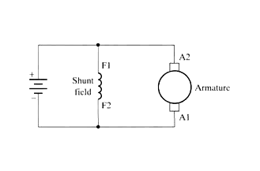

**Speed-Torque Characteristics of a DC Shunt Motor**

The speed Torque characteristics have a small linear drop due to the Armature Resistance (Ra). i.e When the torque increases (T=KϕIa) the Armature Current (Ia) also increases causing more IaRa drop. So Back e.m.f reduces (Eb=V-IaRa). Thus speed will reduce (N= *K Eb )*

*ϕ*

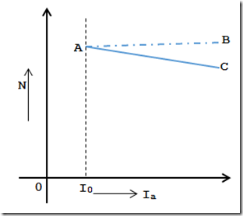

Considering Armature reaction into effect, the field will get weakened due to Armature reaction. So the speed of the motor slightly increased.

**Applications**

1. Shunt motors are suitable for driving light machines tool for all purpose where constant

speed is required.

2. They are used in water pumps; Saw mills, blowers, lathes, wood working machines etc.

**DC SERIES MOTOR**

In the DC series motor the field winding is connected in series with the armature winding as shown in the figure. The series field winding is made up of thick wires of few turns. The current taken by the motor

**IL=Ia=Ise**

**V=Eb+IaRa+IseRse**

**V=Eb+Ia(Ra+Rse)**

When the load increases the Back e.m.f decreases. So the current through armature and field increases causing a large field flux. The speed of the motor will decrease because speed is inversely proportional to the flux.

**Here Tα ϕ I**

**ϕαI**

**So TαI2**

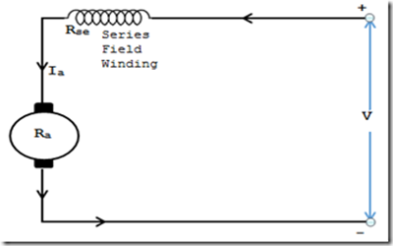 At no-load the motor current and hence the flux/pole tends to zero as consequence, the motor speed tends to increase infinity. Hence series motor must never be allowed to run at no load even accidentally. As the load increases the speed drops heavily, causing increased torque.

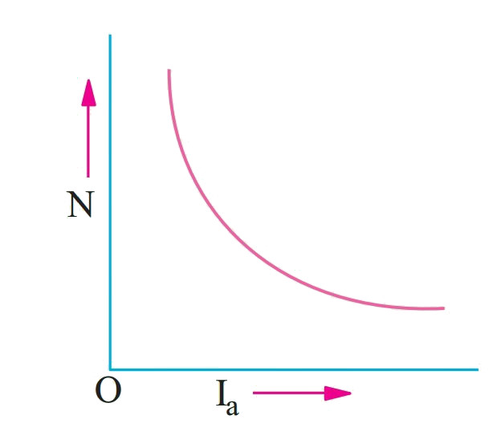**Speed-Torque characteristics of a DC Series Motor**

The field current and field flux will increase with increases in torque. The speed reduces because speed is inversely proportional to the field flux. This type of speed torque characteristic is called series and is ideally suited for traction, cranes etc.

**Applications**

1. Because they provide very high torque they are used for accelerating heavy masses

quickly, for electric traction, and hoist work.

2. They are used in electric trains, Cranes, Lift etc.

**Compound-Wound motors**

In a Compound-Wound motor there are two field windings, one of them is connected in series with the armature and the other is connected in parallel with the armature. There are two types of compound wound motors.

**a) Differential Compound-Wound Motor**

**b) Cumulative Compound-Wound Motor**

**a) Differential Compound-Wound Motor**

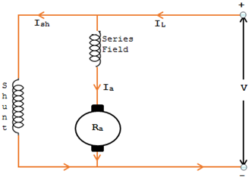

Here the series field is connected in the circuit so as to oppose the flux produced by the shunt field winding. Differential Compound-Wound Motor has lower torque and rarely used.

**Speed-Current Characteristics.**

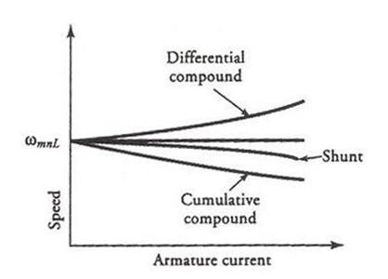

**Disadvantages**

1. For a heavy load the series field winding draws a heavy current from the supply. Thus

causes the total flux to reduce low value. Therefore, it attains dangerously high speed.

2. When motor is started, the shunt field takes some time to build up the field flux. This may

cause the armature to rotate in the reverse direction

**b) Cumulative Compound-Wound Motor**

In a Cumulative Compound-Wound Motor fluxes produced by series and shunt winding are additive.

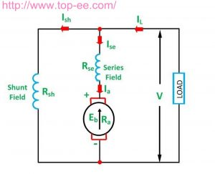

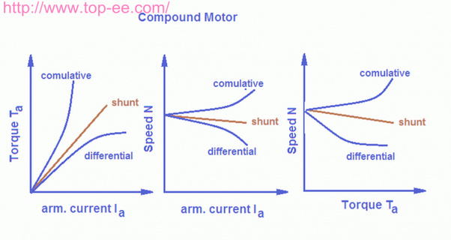 When load on the motor is increased the flux produced by the series winding increases and total flux is increased. But this increase is very small because the shunt winding produces major portion of the flux. Therefore motor gives almost constant speed for different loads.

**Applications**

1. Used largely for driving heavy machines tools where sudden deep cuts may taken and for

continuous rolling mills.

2. They are use where good starting torque and constant speed is required. It is also used where the load varies from zero to maximum. Thus useful for punch press, crushers, compressors, refrigerator plants etc.

**Comparison of different types of motors**

|  |  |  |
| --- | --- | --- |
| **Type** | **Characteristic** | **Application** |
| *Series* | a) Speed decreases with load increase  b) High starting torque  c) Load should be constant & started on load. | Used for generating large torque.  Used in electric trains, Cranes, Lifts etc. |
| *Shunt* | a) Constant Speed  b) Starting torque is less but running torque is good.  c) Started without load. | Used for constant speed application.  Used for wood working machines, water pumps, Lathe, Sawmills etc. |
| *Cumulative compound* | a) Variable speed  b) High starting torque | Used in rolling mills, big presses, heavy tool machines, printing machines etc. |

**Motor Starters**

When a motor is connected to the supply heavy current flows through the armature winding since there is no back e.m.f at the time of starting. This may damage armature. Hence a starter is necessary which allows less current at the time of starting and gradually allows the rated current to the armature. Therefore to start a DC motor a starter having a variable resistance is required.

DC shunt or compound motors are using the following types of starters.

**a) DC three point starter**

In a three point starter the current through the armature winding is supplied through series resistor initially. The current through the field winding is supplied directly. As the motor attains its normal speed the resistors are gradually cut-off using a mechanical arrangement.

**b) DC Four point starter**

These type of starters are used where much speed regulation is required. The construction of this type starter is almost similar to that of a three-point starter.

DC series motor is stared by DC two-point starter.

**Speed Control of Shunt Motors**

In a DC Motor the speed N is given by N= *K Eb .* So in order to control the speed of

*ϕ*

the motor, back e.m.f or field flux has to be controlled. There are three methods used for speed control of Shunt Motors. They are:

1. Armature Control Method.

2. Field-Control Method.

3. Voltage Control Method (Ward Leonard System)

**1. Armature Control Method**

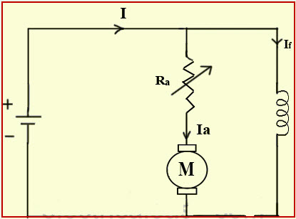

In this method a series variable resistor is connected to the armature to reduce the amount of back e.m.f. As the value of series resistor increases the back e.m.f decreases causing reduction in speed. So this method can be used for lowering speed of the motor.

The main disadvantage of this system is the large amount of power loss (I2R Loss) in the controlling resistor.

**2. Field-Control Method**

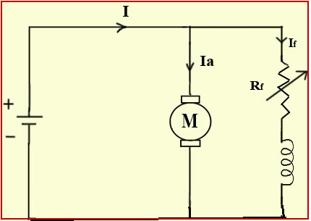

In this method a series variable resistor is connected to the field winding to reduce the field current. The field flux reduces with field current. The speed of the motor is inversely proportional to the field flux. So this method can be used for increasing the speed of the motor. This method is very efficient because the power loss across the variable resistor is small due to small field current.

**3. Voltage Control Method (Ward Leonard System)**

In this method the armature is directly supplied with a variable voltage source. The variable voltage source is a DC Generator set. (The DC generator set is a Motor-Generator set in which a **DC/AC motor** is coupled with a **DC generator**. i.e when supply is given to DC/AC motor, the motor rotates the generator coupled with it)

By changing the voltage across the armature the speed control can be obtained. The voltage of the generator set is varied by varying its field current.

This method is less efficient. But it can be used where the speed should be maintained accurately. Eg: *Elevators, Mines, Hoists etc.*

**Speed Control Of Series Motors**

The speed control of series motor can be obtained by changing field current. The change in field current results in a change in field flux that leads to change in speed. This can be done by different methods.

1. Armature Diverter

2. Field Diverter

3. Voltage Control Method

**1. Armature Diverter**

In this method a variable resistor is connected in parallel with the armature to divert armature current. The armature current varies with the variation of the resistor. This causes increase in field current and field flux. Thus the speed of the motor will get reduced.

**2. Field Diverter**

A resistor is connected in parallel with the field winding to divert the field current. This will cause a reduction in the field current that results to an increase in the speed.

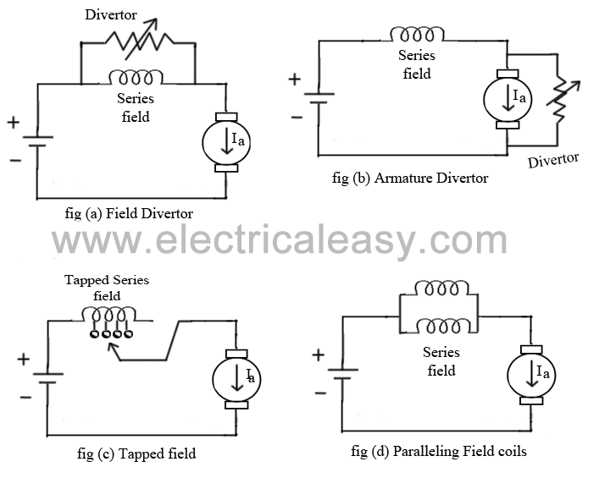

**3. Voltage Control Method**

In this method a series variable resistor is connected to the whole motor circuit. By varying this resistor the effective voltage across the motor terminals can be varied. This results in the speed change. This method is commonly used for DC ceiling and table fan.

**\*\*\*\*\*\*\*\*\*\*\*\*\*\*\*\***

**CHAPTER 7**

**AC MOTORS**

Conversion of electrical power into mechanical power take place in the rotating part of an electric motor. In DC motor electric power is conducted directly to the armature. Hence it can be called conduction motor.

In AC motor the rotor does not receive electrical power by conduction but by induction, that is why AC motor are known as induction motor. The motors which works by AC power supply is known as AC motor or induction motor. These are mainly three types of induction motors.

1. Single phase induction motor

2. Three phase or asynchronous induction motor

3. Synchronous motor

**Three phase induction motor**

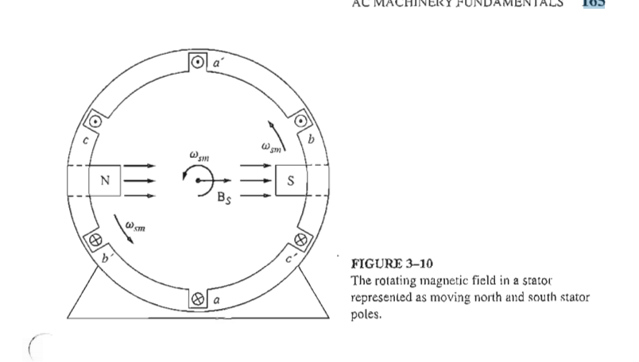 They are self starting motors. Low cost, simple construction, high efficiency, reasonable good power factor, low maintenance cost and simple starting arrangements.

**Working principle of three phase motors**

There are three stator winding in a three phase induction motor. This windings are placed 120. apart from each other. These winding carry balanced three phase alternating current. **Ea= EmSinωt**

**Eb=EmSin (ωt-120º)**

**Ec=EmSin (ωt-240º)**

The three pulsating mmf waves are now set up in the air gap by the three windings. The resultant mmf can be found out by adding the mmf set up by the coil a,b and c. The resulting mmf rotates at constant speed of omega radiance per second. The direction of rotation can be reversed by interchanging any two phases. The speed of the rotating magnetic field produced in the stator winding is given by

**Ns = 120f/ p**

This speed is known as synchronous speed. When three phase supply is given to the stator winding of an induction motor, a rotating magnetic field of constant speed is set up. This rotating field produces induced emf in the rotor conductor and high current flows through rotor winding. According to the lenses law this induced current will oppose the cause of which is inducing the current. Here the cores producing the rotor current is the relative motion between rotating magnetic field of stator and stationary rotor. Hence to reduce the relative motion of the rotor current produce torque and the rotor rotates in the same direction of the field.

**Rotor slip**

The difference in speed of stator magnetic speed and rotor speed is called absolute slip. The speed of the rotor is slightly less than the speed of stator field because if both field are equal there will be no relative motion and thus no rotor current and torque. Further at no load some torque is required to overcome friction , windage. The speed of the rotor will be reduced with increase in load. If Ns is the speed of the stator magnetic field and Nr is the speed of the rotor then

**Absolute slip = Ns -Nr**

**S= Ns -Nr**

When slip is represents as fractional slip.

**S= Ns-Nr**

**Ns**

The percentage of slip is

**%S= Ns-Nr X 100**

**Ns**

**Rotor frequency**

When the rotor is at rest the frequency of emf induced in the rotor will be maximum. As the rotor speed increases the rotor frequency reduces. That is rotor emf frequency.

**Rotor e.m.f frequency f'= Relative_Speed(rpm) = Ns - Nr**

**120/P 120/P**

**Ns= 120f**

**P**

**Slip S = Ns - Nr = f'**

**(120f)/P f**

**Sf** = **f'**

**Types of polyphase induction motor**

Three phase induction motors called asynchronous motors because the rotor does not rotate at the speed of magnetic field. There are three types of induction motors.

**1. Squirrel cage induction motor**

**2. Slip ring type induction motor phase wound motor**

**1. Squirrel cage induction motor**

A three phase squirrel cage induction motor has two parts called stator and rotor

**Stator**

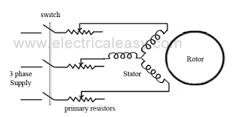 The stator of an induction motor is wound for three phases similar to that of a three phase alternator. The stator consist of silicon laminations insulated from each other. it is hollow and cylindrical in shape having slots in its inner surface to carry windings. Three phase supply is given to the stator windings through terminal box.

**Rotor**

The rotor consist of a number of copper conductors inserted in slots of a laminated rotor core. The ends of these conductors are connected to copper rings. this arrangement of conductors resembles to the cage of a pet squirrel. This type of rotor has very low resistance and it is cheaper compared to other types. The squirrel cage rotor is used for small motors.

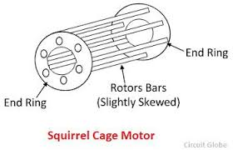

**Working principle**

When a 3 phase supply is given to the stator a rotating magnetic feild is set up. The rotor conductorscut the magnetic feild and induce emf in them. This causes heavy current flow through the rotor conductors due to low resistance of the rotor. These currents will produce torque which rotates the rotor in the same direction of the feild.

At the time of starting, frequency of the induced emf in the rotor is maximum. Sf = f'

so the reactance of the rotor is high compared to the rotor resistance.When the rotor attains full speed the rotor frequency is lowerd.

* These are constant speed motors
* They can started without load
* used in water pumps, drill machines, grinder, saw mills, flour mills

**Slip ring induction motor**

**Construction and working:**

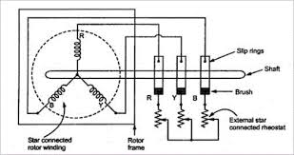 In a slip ring type induction motor the stator is similar to that of a squirrel cage induction motor and is wound for three phase. The rotor also has a three phase winding which is usually connected in star. Three ends of the rotor winding are brought out using three slip rings, which are insulated from each other and the rotor shaft. External rheostatic resistance that are connected in star are attached to these slip rings using carbon brushes. These resistance increase rotor circuit resistance , which results in high starting torque. These resistance are gradually cut off from the rotor circuit as the motor attains its normal speed. Therefore, during running the rheostatic resistances are zero which results in a good running torque. Slip ring type are more costly as compared to squirrel cage rotor because it is difficult to construct them. Since the rotor circuit resistance is high during starting, they produce a very high starting torque.

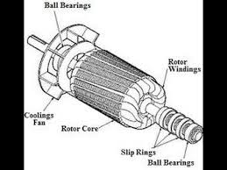

**Applications**

* They are used at places where high starting torque is required such as plainer, cranes, rolling mills, lifts. These motors are started on load.

**Speed control of induction motors**

* Varying the applied voltage across motor terminal (voltage control).
* Varying the applied frequency (frequency control):- the synchronous speed of induction motor is directly proportional to the frequency. So by varying the frequency of the applied voltage the speed of the motor can be controlled (Ns = 120f/p)
* By varying the number of poles
* Rotor rheostat control method:- the speed of the slip ring type induction type can be controlled by this method. This method is commonly used because of high I2R loss in the rheostatic resistors.

**Three phase induction motors starters**

When a motor starts there is a chance for the flow of very large current through the stator winding. This may causes damage to the stator winding. To reduce this overflow of current through the stator winding an electrical circuit called starter are used. A starter also protect the winding from over voltage , overload etc. The main kinds of starter are

* Direct online starter
* Star delta starter
* Auto transformer starter
* Slip ring motor starter

**Direct online starter**

In this no arrangement to limit the starting current. Full voltage will be appear across the motor at the time of starting. It has two parts

**A no- volt coil:-** When this coil is energised it will attract a plunger and thus the motor starts. If there is a supply failure then the plunger will disconnect the motor.

**A start push button:-** When upnormal current flows through them the bimetalic strip will open the circuit.

**Star delta starter**

In this the stator windings are initially connected in star and when the motor attain its rated speed it connected to the delta. When connected it start the voltage across each winding will be reduced to line voltage/√3. So the starting current is also reduced to 1/3 of current in delta connection. In manual star delta starter the stator windings should be switched from star to delta manually. But in an automatic star delta starter the windings will be changed automatically from star to delta after few seconds.

**Auto transformer starter**

The supply voltage is reduced by an auto transformer at the time of starting. When the motor attains its normal speed the auto transformer gradually cut off from the circuit.

**Slip ring motor starter**

In this external rheostatic resistors are put in series with the rotor winding at the time of starting. So the starting current can be minimized and rotor power can be improved. Thus a high starting torque can be obtained. When motor attains its full the resistor are gradually cutt off from the circuit.

**Single phase motor**

Single phase motor has only one stator winding. When a single phase AC is given to this winding a magnetic field is set up which changes in magnitude and direction sinusoidally. If we apply a single phase to the stator the rotor only jerk, to rotate the rotor we use some methods. According to this method motors are classified as

* Shaded pole motor
* Split phase motor
* Repulsion type motor
* Universal motor

**Shaded pole motor**

In this type a no of copper rings attached to the stator pole. These rings produce a lag in the flux produced by the pole. This changes in flux rotates the rotor.These type motors have low starting torque. This direction of rotation of these type motors cannot be changed. They are used in small table fans, ceiling fans.

**Split phase motor**

In a split phase motor the stator contains two windings starting winding and running winding. These are placed by 90 physically. When AC supply is given a phase difference takes place and will rotate the rotor. The phase difference can be achieved by connecting a series capacitor to any one of these windings. They are four types of split phase motors.

* **Split phase induction motor**
* **Capacitor motor**
* **Capacitor start induction motor**
* **Capacitor start capacitor run motor**

**Repulsion motor**

When a shorted coil is placed in a magnetic feild a torque will produce and it will repel that coil.This principle is used in this motors

**Universal motor**

They are works on AC and DC. If through a DC series motor AC is passed it will develop a torque which always unidirectional because the current in the both armature and field winding changes simultaneously.

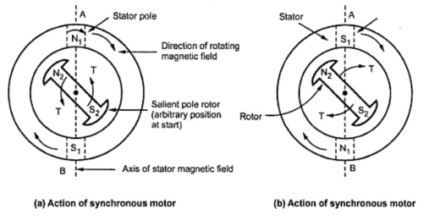**Synchronous motor**

The speed of the synchronous motor is exactly equal to the synchronous speed of the stator. They are not self starting motors. They must be started using another induction motor.

**Working principle**

When an AC supply is given to the motor the poles of the rotor will change according to the frequency of the supply. In figure (a) the rotor poles tend to attract towards the stator poles. The rotor tries to rotate in clockwise but this time the rotor pole have change their polarity. So the rotor moves back to the initial position. It is indicated in figure (b). The rotor of a synchronous motor will vibrate only when single phase is given to it. But if the rotor is made to move to the next stator pole (same pole) it will start running. So the rotor of the synchronous motor must be rotated at a synchronous speed (120f/p).

**Advantages**

* It is a constant speed motor
* It improve power factor

**Disadvantages**

* It cannot be used for variable mechanical load.
* This motors are not self starting type
* It cannot be started with no load
* To operate the motor its feild system require dc supply
* Cannot be used for variable speed

**Applications**

* power stations
* substations
* Big industries

**\*\*\*\*\*\*\*\***

**CHAPTER 8**

**GERNERATION AND DISTRIBUTION**

**POWER STATIONS**

Electrical energy is generated at power stations. A power station converts natural sources of energy to Electrical Energy. The Electrical Energy thus generated is transmitted to substations and then distributed to consumers. Different natural sources of energy are:

***a) Kinetic Energy of wind and water.***

***b) Chemical energy of fuels.***

***c) Nuclear energy of radioactive substances.***

***d) Solar energy (Energy radiated from sun in the form of light).***

**The sources of energy can be classified as follows.**

1. Primary sources like sun, wind and tide. These sources may be useful only at the places

where weather remains clear.

2. Secondary sources like coal, oil, water and radioactive substances.

**The power stations utilizing the secondary sources of energy are:**

a) Hydro electric Power Station

b) Thermal Power Station

c) Diesel Power Station

d) Atomic Power Station

**Comparison of different types of Power Station**

**1. Initial cost**

A power station employing fuel has low initial cost; a hydroelectric Power Station has moderate initial cost while nuclear Power Station has very high initial cost.

**2. Running cost**

The running cost of hydroelectric Power Station is less than that of thermal and diesel Power Station but higher than nuclear Power Station.

**3. Limit of source of energy**

The source of energy for hydroelectric Power Station (water) is not dependable. Similarly coal, diesel or nuclear sources are limited.

**4. Simplicity and cleanliness**

The hydroelectric Power Stations are cleanest and simplest. There is no smoke , ash or radiation.

**5. Reliability**

The source of energy for hydroelectric power station is not reliable.

**a) Hydro-electric Power station**

A hydroelectric power station converts kinetic energy of water to electrical energy. Water stored in a high level reservoir is brought down through spiral pipes. Kinetic Energy of the water rotates a water turbine. When turbine rotates the generator coupled with the turbine also rotates. The generator used for this system runs at low speed and has more number of poles. The generated voltage is usually 11KV to 33KV.

The system can be implemented to rivers that have no shortage of water throughout the year.

Example: Bhakra Dam, Hirakud, Idukki.

**Advantages of Hydroelectric Power Station**

1. The running cost is comparatively less than the initial cost.

2. They have constant speed and constant frequency.

3. They have longer life. 4. They are neat and clean.

5. It can be put into service instantly.

6. Such plants in addition to generation of electrical power also serve other purpose such as

irrigation.

**Disadvantages**

1. Requires large area of land. 2. Construction cost is very high.

3. Long dry seasons may affect the power station.

4. High cost for transmission lines.

**B) Thermal Power Stations**

In a thermal power station the chemical energy of coal is converted to electrical energy. The coal is burned and its heat energy is used to generate steam in a steam boiler. This steam is used to drive a steam turbine. The turbine drives generator. The steam after doing its work in the turbine is condensed to water for recycling in the boiler. These types of power stations have medium capacity and their initial and running costs are comparatively high.

Eg: Indrapstaha at Delhi, Kayamkulam thermal power station.

**c) Diesel power stations**

A diesel engine (Internal Combustion Engine) is used to drive the generator. These types of power stations are commonly used where the demand of power is very less. They are used in deserts; hilly areas, war field areas and military camps. They have high initial and running cost.

**Advantages**

1. Quick starting of the system.

2. Occupies less space.

3. They can be used as standby or emergency power source in conjunction with main supply.

**d) Atomic Power stations**

Here the energy is obtained by nuclear fission. A nuclear fuel (like Uranium 235) when hit by a neutron, split into two and releases energy. This heat energy is carried away by a coolant (Water, Heavy water etc.). The coolant carries large heat energy, which is used to produce steam. The steam drives a steam turbine, which is coupled, to a generator. Commissioning cost of these, types are very high but running cost is comparatively lower than a thermal power station. The output capacity of an atomic power station can be very high.

E.g. Narora, Trombay.

**Elements of a hydroelectric Plant:** A hydroelectric plant consists of a diversion dam, a conduit to carry water to the water wheel, the powerhouse, its equipments and a tailrace. The various components of hydroelectric plants are:

**1. Catchment area**

It is the area over which the rainfall is collected and led to the reservoir.

**2. Water reservoir**

A dam is constructed across a river at a suitable place and the water is stored.

**3. Dams**

The Dam may be either impounding (Non overflow) type or spill-way (over flow). In case of non-overflow type dams, means are provided to release excess flow by a separate spillway section, by regulating valves or by large spillway gates.

**4. Spill way**

This is constructed to act as a safety valve. It discharges the overflow water to the downstream side when reservoir is full. These are generally constructed of concrete and provided with water discharge opening and shutoff by metal control gates.

**5. Intakes**

It may consist of canals, flumes, pipelines, pressure tunnels with or without fore bays *(Fore bays provide a small amount of reservoir capacity to take care of variations of load).* Sometimes surge tanks were provided instead of fore bays.

**6. Penstocks**

It is a closed conduit, which connects the fore bay or surge tank to the scroll of the turbine. In case of medium head, power plants each unit is usually provided its own penstock. But in high head plants single penstock is used and branch connections are provided at lower ends. Penstock is build up of steel or reinforced concrete.

**7. Valves and Gates**

These are normally used to shutoff the flow and for un watering the turbine in case of inspection or repair.

**8. Racks**

These are usually built up from long flat bars set vertically having a clear space of 25-250mm between them. They are used to prevent floating materials to the turbine.

**9. Tail Race**

The water having done its useful work in the turbine is discharged to the tailrace, which may lead it to the same stream or to another one.

**10. Draft tube.**

It collects water down from the wheel and discharges it under the surface of water to the tailrace. It is an airtight pipe.

**11. Prime mover**

From the penstock, water is taken to the turbine and the water turbine converts kinetic energy of water in to mechanical energy. According to the action of water on moving blades, water turbines are of two types namely *impulse and reaction type turbines.*

When the entire pressure of water is converted into kinetic energy in a nozzle and the jet thus formed drives the wheel, then the turbine is *Impulse type* (Pelton Wheel). If water pressure combined with its velocity work then turbine is *Reaction type*.

Impulse type turbines are used for high head power station and reaction type for low & medium Power Stations.

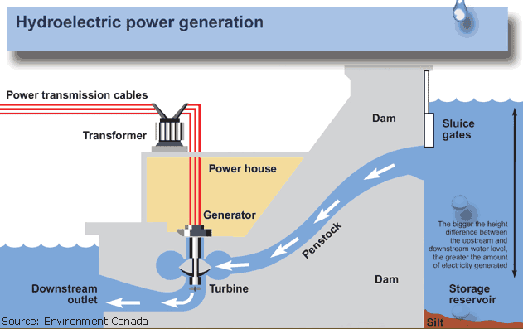**12. Alternator & Exciter**

The alternator is coupled to the water turbine and it converts the mechanical energy to electrical energy. The exciter for exciting field coils of the alternator is a DC compound generator mounted on the same shaft of the alternator.

**Transmission of electricity**

The electrical energy is generated at the Power Stations and is utilized by the consumers located at different places. Hence a system called transmission and distribution system is required to deliver the power from power stations to various consumers.

**Transmission System.**

Transmission system delivers large quantities of electrical power from one place to other. It delivers bulk power from Power Stations to the load centres and large industrial consumers. In order to minimize the transmission loss usually transmission voltages are made very high. Primary transmission delivers power from power stations to grid stations and primary transmission voltage is typically 220KV. Grid stations deliver power to substation through secondary transmission lines where the transmission voltage is 33KV.

**Distribution System**

The distribution system delivers power to various consumers. The substations distribute the power to consumers through distribution transformers. Voltages of Primary and Secondary distribution lines are 11KV and 440V. The power is usually transmitted at high voltages, which has the following advantages.

**Advantages of high voltage transmission**

***a) Saving conductor material***

For a constant power output if the transmission voltage is increased the current in the transmission line reduces. This reduces the size of conductor required.

***b) Reduction in power loss of transmission line***

As the current reduces the power loss in the line also reduces (P=I2R)

***c) Better efficiency***

Due to the decrease in power loss efficiency of the transmission line is increased.

***d) Better voltage regulation***

Transmission at high voltage reduces voltage drop of the line due to decrease of current and thus improves voltage regulation.

***e) Saving of material***

With saving of conductor the size of the cross arm, number of poles required etc. can be reduced, minimizes the cost.

**Overhead Systems And Underground Systems**

Transmission and distribution of electrical power can be carried out by overhead as well as underground systems.

**Overhead System**

Supply line are taken above the ground on poles in this system. It is cheaper in initial cost, more flexible. This system can be operated up to 400KV where underground system cannot be operated above 66KV, because of its insulation difficulties. This system can be overloaded as the conductors are exposed in the air.

**Advantages**

1. Very Cheap. 2. Easy to locate faults.

3. Branch connection can be taken out easily.

**Disadvantages**

1. Maintenance cost is high.

2. Chances of being short circuited in case of storm and may cause fire.

3. Difficult to install at narrow places.

4. Not good looking.

**Underground Systems**

Insulated cables run underneath the ground carries electricity in this system. This system is safe, good looking and maintenance cost is comparatively lesser. There is no chance for accidents as in the case of overhead system.

**Advantages**

1. Low power factor loss.

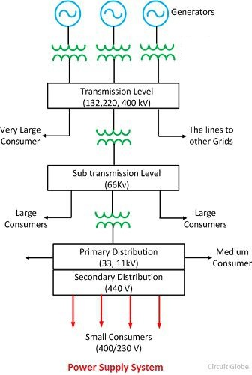2. Good safety for human life.

**Disadvantages**

1. Installation cost is high.

2. Difficult to trace faults.

3. Less flexible.

**Single line diagram of complete supply system.**

Figure shows one line diagram of a complete supply system. The generating voltages are 3.3, 6.6 and 11KV. It is then stepped-up to 220KV or152 KV or 132KV and transmitted to grid stations through primary transmission lines. The grid stations step down this voltage to 33KV and transmitted to substations through secondary transmission line.

The substation distributes the power to various distribution transformers after stepping down the voltage to 11KV. Distribution transformers further step down the voltage to 440V and deliver the power to consumers.

**Different Sections of supply system are**

***1. Feeder mains***

Feeder mains are used to deliver power from generators to transmission lines.

***2. Transmission feeders***

The transmission feeders carry electrical power at high voltage. They carry power from generating stations and delivers to substations. Normally transmission feeders are placed on transmission towers.

***3. Distribution line***

They are used to deliver energy from substations to various consumers. They are normally underground or overhead cables.

**Distribution System**

To deliver electrical power to various consumers distribution systems are required. Different distribution systems are:

**1) Radial Distribution 2)Ring Distribution 3) Grid distribution**

**1. Radial system**

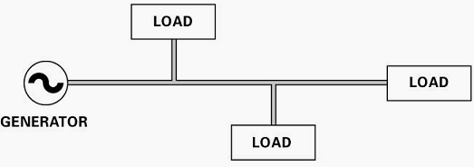 In this system each load is supplied by individual feeders. The system is used for low voltage distribution. Here the generator is placed at the centre of the load. The system is very simple but in case of fault in the main feeder, the whole supply will be interrupted.

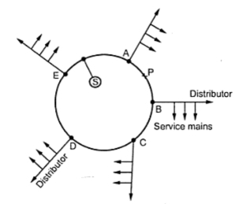**2. Ring system**

Here a ring feeder is used for distribution. Each load centres will receive power from two sides. In case of fault in one side of the feeder, the power can be supplied to load centre through the other side. The faulty section can be easily disconnected without interrupting distribution. This system can be used for low and high voltage distribution.

**3. Grid System**

This system is also called **interconnected distribution system**. Here all the generating stations and substations are interconnected. In this system the power can be easily supplied to a load centre from various generating stations during the time of need. The transmitted voltage is stepped down to 33KV and then it is applied to distribution main from grid stations.

**Classification of Overhead Lines Based on Voltages**

1. Low Tension - Voltage does not exceed 250V (0-250V)

2. Medium Tension - Voltage does not exceed 650V (250V-650V)

3. High Tension - Voltage does not exceed 33KV (650V-33KV)

4. Extra High Tension - Above 33KV.

**Classification of Under Ground Cables**

**Types of cables**

1. Low Tension cables (LT) - Up to 1000V

2. High Tension (HT) - Up to 11KV

3. Super Tension (ST) - 22KV - 33KV

4. Extra High Tension (EHT) - 33KV to 66KV

5. Oil filled and gas filled pressurized cables - 66KV to 132KV or above.

**Classification of transmission lines based on distance**

Generally transmission lines are classified into three -

***1. Short***

***2. Medium***

***3.Long***

**1. Short**

Transmission lines having length lesser than 80Km and operating voltage lower than 220KV fall into this category. Due to shorter distance and lower operating voltage the capacitance effects are extremely small and can be neglected.

**2. Medium**

Transmission lines having length between 80Km and 150Km and operating voltage between 20KV and 100KV fall into this category. The capacitive effect should be taken in to account for this type of lines. The capacitance may be assumed to be concentrated at one or more points.

**3. Long**

The transmission lines having length above 150Km and operating voltage above 100KV fall in this class. In this line impedance and admittance (1/Z) are to be considered uniformly distributed.

************